
Faculty of Informatics Engineering
Department of Informatics Eng

Syrian Services Hub
A senior 2 project report - submitted to complete the requirements for obtaining a Bachelor’s Degree in informatics engineering

Prepared by
Lilas Nakhal

Supervised by
Dr.Akram Masouh Eng.Amer Khorheed

Academic Year
2026


كليــــــــــــــــــة الهندســــــــــــــــــــــــة
قســــــــم هندسة البرمجيات ونظم المعلومات

منصة السورية الذكية

مشروع تخرج 2 - مُقدَّم لاستكمال متطلبات الحصول على درجة البكالوريوس في هندسة المعلوماتية
قسم البرمجيات ونظم المعلومات

إعداد
ليلاس محمد سامر نخال
إشراف
د.أكرم مسوح م.محمد عامر خورشيد

العام الدراسي
2026

SUPERVISION CERTIFICATION

Supervisor Certification I Certify that the preparation of this project entitled
[ Syrian Services Hub]
Prepared by
[Lilas Nakhal]
Were made under our supervision at Faculty of Informatics Engineering in partial Fulfillment of the Requirements for the Degree of Bachelor of Software and Information system Engineering

Name: ………………………………. Name: ………………………………………….

Signature: ……………………………………. Signature: ……………………………….

Abstract

Modern service platforms are no longer limited to displaying services; they are expected to understand user needs and guide them toward the right solution quickly and intelligently. From this perspective, Syrian Services Hub introduces an integrated digital platform that connects users with service providers in an organized, reliable, and user-friendly environment.
The system allows users to create accounts, browse services, search for service providers, request existing services, or post custom service request advertisements when the needed service is not currently available. Users can also receive offers from providers, communicate through the internal chat system, and rate services after completion.
A key feature of the project is the integration of artificial intelligence. Users can describe their problem or need in natural language, and the system suggests suitable solutions while recommending relevant service providers from within the platform. This makes the process of finding the right service smarter and easier.
Service providers can manage their professional profiles, add services, submit offers on user requests, and track their activity through a dashboard that displays statistics, earnings, and ratings. The admin side also provides tools for managing complaints, verification requests, accounts, and platform analytics.
As a result, Syrian Services Hub is not just a service-request platform, but an intelligent digital ecosystem that combines requesting, offering, communication, evaluation, administration, and AI-based recommendations in one place.
In addition to the AI recommendation feature, Syrian Services Hub includes a separate Retrieval-Augmented Generation (RAG) capability named Ask Assistant. An authenticated user can ask a factual question about a selected provider or service, and the system retrieves only active, authorized provider-owned knowledge sources before generating a grounded answer with source citations. When the available evidence is insufficient, the assistant returns a clear insufficient-evidence response rather than inventing information. The two intelligent capabilities serve different purposes: AI Recommendation suggests suitable solutions and providers, whereas Ask Assistant answers evidence-based questions about a provider or service.

ملخص

لم تعد منصات الخدمات الحديثة تكتفي بعرض الخدمات فقط، بل أصبحت مطالبة بفهم حاجة المستخدم وتوجيهه نحو الحل المناسب بسرعة وذكاء. ومن هذا المنطلق، يقدم مشروع Syrian Services Hub منصة رقمية متكاملة تربط بين المستخدمين ومزودي الخدمات ضمن بيئة منظمة، موثوقة، وسهلة الاستخدام.
يتيح النظام للمستخدم إنشاء حساب، تصفح الخدمات، البحث عن مزودي الخدمات، طلب خدمة موجودة، أو نشر إعلان عن خدمة يحتاجها في حال لم تكن متوفرة على المنصة. كما يستطيع المستخدم استقبال العروض من مزودي الخدمات، التواصل معهم عبر نظام المحادثة، وتقييم الخدمة بعد الانتهاء منها.
يميز المشروع دمج الذكاء الاصطناعي، حيث يستطيع المستخدم كتابة مشكلته أو حاجته بلغة طبيعية، ليقوم النظام باقتراح حلول مناسبة وترشيح مزودي خدمات من داخل المنصة، مما يجعل تجربة البحث عن الخدمة أكثر ذكاءً وسهولة.
أما مزود الخدمة، فيستطيع إدارة ملفه المهني، إضافة خدماته، تقديم عروض على طلبات المستخدمين، ومتابعة نشاطه من خلال لوحة تحكم تعرض الإحصائيات والأرباح والتقييمات. كما يوفر النظام للأدمن أدوات لإدارة الشكاوى، طلبات التوثيق، الحسابات، ومراقبة أداء المنصة من خلال لوحة تحكم تحليلية.
وبذلك لا يُعد Syrian Services Hub مجرد منصة لطلب الخدمات، بل منظومة ذكية تجمع بين الطلب، العرض، التواصل، التقييم، الإدارة، والتوصية الذكية في مكان واحد.
إضافةً إلى ميزة AI Recommendation، تتضمن منصة Syrian Services Hub ميزة مستقلة تعتمد على تقنية التوليد المعزز بالاسترجاع (RAG) باسم Ask Assistant. تتيح هذه الميزة للمستخدم المسجل طرح سؤال واقعي حول مزود خدمة أو خدمة محددة، ثم يسترجع النظام فقط مصادر المعرفة الفعالة والمملوكة لمزود الخدمة والمصرح بعرضها قبل توليد إجابة موثقة بمراجع المصدر. وعند عدم كفاية الأدلة، يعرض المساعد رسالة واضحة تفيد بعدم توفر معلومات كافية بدلاً من اختلاق إجابة. وتؤدي الميزتان الذكيتان وظيفتين مختلفتين: تقترح AI Recommendation الحلول ومزودي الخدمات المناسبين، بينما يجيب Ask Assistant عن الأسئلة المستندة إلى الأدلة حول مزود الخدمة أو الخدمة.

Contents
Section 1 Project Introduction 14
Chapter One: Introduction 15
1.1 Project Overview and Background 15
1.2 Problem Statement and Significance 15
1.3 Project Objectives 16
1.4 Scope, Constraints, and Assumptions 16
1.5 Project Contribution 17
1.6 Research Methodology 18
1.7 Document Structure 18
1.8 Definitions and Key Concepts 19
Chapter Two: Project Development and Management Methodology 20
2.1 Selected Development Methodology and Justification 20
2.2 Project Timeline and Work Plan 20
2.3 Risk Management 21
2.4 Team Roles and Task Distribution 22
2.5 Quality Management in the Project 23
2.6 Project Management Tools Used 23
2.7 Monitoring and Continuous Evaluation Mechanisms 24
2.8 Software Configuration Management 24
Section Two: Theoretical Study and Analysis 25
Chapter Three: Literature Review and Comparative Study 26
3.1 Related Work in Smart and Similar Service Platforms 26
3.2 Modern Technologies and Frameworks in the Domain 26
3.3 Comparative Analysis of Existing Platforms 27
3.4 Research Gap and Proposed Innovation 28
3.5 Theoretical Background and Reference Foundations 29
3.6 Modern and Future Trends in the Domain 29
Chapter Four: Requirements Analysis and Modeling 31
3.7 Retrieval-Augmented Generation for Provider Question Answering 31
4.1 Feasibility Study 31
4.2 Requirements Gathering 32
4.3 Stakeholders and Needs Analysis 32
4.4 Functional Requirements 33
4.5 Non-Functional Requirements 39
4.6 Requirements Prioritization and Management 40
4.7 UML Requirements Modeling 41
4.8 Modeling According to the Selected Methodology 55
4.9 Requirements Analysis and Documentation 57
Section Three: Design and Architecture 65
Chapter Five: System Architecture and Design 66
5.1 High-Level System Design 66
5.2 Database Design 70
5.3 External API Design 74
5.4 Security and Access Design 75
Section Four: Implementation and Testing 77
Chapter Six: Implementation Environment and Tools 78
6.1 Software Tools and Libraries Used 78
6.2 Development Environment and Project Structure 79
6.3 Programming Languages and Frameworks 80
6.4 Database Server and Operating System 81
6.5 Dependencies 81
6.6 Version Control and Source Management Tools 82
6.7 Continuous Integration and Deployment Tools 83
6.8 Testing Environment 83
Chapter Seven: Software Implementation 85
7.1 Project Structure and File Organization 85
7.2 Implementation of Major Functional Modules 86
7.3 API Implementation 87
Request Processing Flow 87
1. Main API Route 88
2. Service Creation Endpoint 88
4. API View Implementation 89
5. Business Rule and Database Creation 90
6. Example Request Body 90
7. Example Response Body 90
7.4 Implementation of the Data-Access Layer 91
7.5 Implementation of the Business-Logic Layer 91
7.6 User Interface Implementation 92
7.7 Implementation of the Intelligent Recommendation-Oriented Functionality 93
7.8 Implementation of Ask Assistant (RAG) 94
Chapter Eight: Testing and Evaluation 96
8.1 Test Plan 96
8.2 Types of Testing 97
8.3 Test Diagrams 98
8.4 Test Results and Analysis 99
8.5 Quality Metrics 109
8.6 Usability Testing 110
8.7 Evaluation Summary 111
Section Five: Results and Recommendations 112
Chapter Nine: Results and Analysis 113
9.1 System Results 113
9.2 Comparative Analysis with Existing Systems 114
9.3 Achievement of Project Objectives 115
9.4 Strengths and Limitations 116
9.5 Key Performance Indicators 116
Chapter Ten: Conclusion and Recommendations 118
10.1 Project Summary and Main Achievements 118
10.2 Difficulties and Challenges 119
10.3 Future Improvements 120
10.4 Recommendations 121
10.5 Closing Statement 122
Section Six: Appendices and References 123
TABLE OF TABLES
table 1 Risk Register 22
table 2Comparative Analysis of Reference Platforms 28
table 3 Stakeholders and Needs Analysis 32
table 4 Functional Requirements 33
table 5 Non-Functional Requirements 39
table 6 Requirements Prioritization 40
table 7 Use Case Descriptions- Submit Complaint 44
table 8 Use Case Descriptions accept or reject offer 44
table 9 Use Case Descriptions submit offer on request 44
table 10 Use Case Descriptions add services 45
table 11 Use Case Descriptions post new request 45
table 12 Increment Plan and User Stories 56
table 13 Story Mapping 56
table 14 Requirements Traceability Matrix 57
table 15 Initial Test Cases-add services 58
table 16 Initial Test Cases send offer 60
table 17 Initial Test Cases post new request 61
table 18 Initial Test Cases sumbit offer on request 62
Table 19 Initial Test Cases Create User Account 63
table 20 Architecture Layer Summary 67
table 21 Core Relational Schema of Syrian Services Hub 71
table 22 Main Database Constraints 72
table 23 Representative API Endpoints 74
table 24 Main software tools and libraries used in the implementation environment 78
table 25 High-level implementation environment structure 79
table 26 Programming languages and frameworks used by the project 80
table 27 Database and execution environment summary 81
table 28 Main dependency groups used by the project 82
table 29 Version control and source-management tools 82
table 30 CI/CD status within the current project scope 83
table 31 Testing environment elements used during implementation 83
table 32 High-level repository structure of Syrian Services Hub 85
table 33 Main implementation modules and their responsibilities 87
table 34 Representative API functions in the implemented system 87
table 35 Data-access responsibilities in the implementation 91
table 36 Representative business-logic responsibilities 92
table 37 Implementation positioning of the recommendation-oriented feature 94
table 38 Test plan overview 96
table 39 Types of testing applied to Syrian Services Hub 97
table 40 Main test cases and validation results add services 101
table 41 Main test cases and validation results submit offer 102
table 42 Main test cases and validation results post new request 103
table 43 Main test cases and validation results submit offer 105
Table 44Main test cases and validation results Create User Account 106
table 45 Quality metrics used in the evaluation 109
table 46 Usability review observations 110
table 47 Comparative analysis between Syrian Services Hub and selected reference platforms. 114
table 48 Achievement of the main project objectives. 115
table 49 Summary of project strengths and limitations. 116
table 50 Suggested KPIs for evaluating Syrian Services Hub. 116
table 51 Summary of main project achievements. 118
table 52 Main project challenges and responses. 120
table 53 Suggested future improvements. 120
table 54 Final recommendations. 121
table 55 Appendix Overview 124

TABLE OF FIGURES
Figure 1 Gantt Chart 21
Figure 2 Main Use Case Diagram for Syrian Services Hub 42
Figure 3 use cae request an exasting service 42
Figure 4 use cae post new request 43
Figure 5 use case submite an offer 43
Figure 6 Post Service Request 47
Figure 7 Activity Diagram - Submit Offer 47
Figure 8 Activity Diagram submit compliant 48
Figure 9 Activity Diagram add services 48
Figure 10 Activity Diagram review incoming offer 49
Figure 11 Sequence Diagram - Submit Offer 50
Figure 12 Sequence Diagram - Submit Offer 51
Figure 13 Sequence Diagram - add services 52
Figure 14 Sequence Diagram -post new request 53
Figure 15 Sequence Diagram -review incoming offer 54
Figure 16 : Sequence Diagram submit complaint 55
Figure 18 System Block Diagram of Syrian Services Hub 67
Figure 19 Architecture of Syrian Services Hub 69
Figure 20 ER Diagram of Syrian Services Hub 70
Figure 21 Placeholder for the project structure 86
Figure 22 Placeholder for a main marketplace interface screenshot. 93
Figure 23 service-request interface screenshot 93
Figure 24 dashboard of Syrian Services Hub. 114

Section 1
Project Introduction

Chapter One: Introduction
This chapter introduces the proposed platform, explains the practical problem it addresses, defines the main objectives of the project, and outlines the intended scope and contribution of the system.

1.1 Project Overview and Background
Syrian Services Hub is a smart digital service marketplace designed to connect service providers with consumers through a structured and accessible platform. The system supports multiple roles, including visitor, user, service provider, and administrator. Visitors can browse the platform and explore available services without submitting requests, while registered users can request services, publish service-demand advertisements, and interact with providers. Service providers can create accounts, publish their services, and submit offers in response to user-posted service requests. The administrator is responsible for monitoring the platform, managing users, reviewing complaints, managing verification status, and supervising the overall operation of the system. In addition to the standard marketplace functionality, the platform includes a dedicated recommendation page where users can write a problem description and receive suggested solutions and a suitable service provider, which strengthens the intelligent aspect of the project and improves the overall user experience.
The platform also contains a second intelligent capability named Ask Assistant. Unlike the AI Recommendation page, Ask Assistant does not rank providers or propose a service direction. It answers factual questions about a selected provider or service by retrieving relevant evidence from authorized provider-owned knowledge sources and returning the answer with citations.

1.2 Problem Statement and Significance
Despite the growing demand for digital services, many consumers still face difficulty in finding suitable service providers through a reliable, organized, and transparent local platform. In many cases, services are scattered across social media pages, personal contacts, and unstructured online groups, which makes the process of searching, comparing, and selecting providers inefficient and uncertain. On the other hand, service providers often struggle to present their services professionally, reach the right audience, and compete fairly in a structured marketplace. This creates a gap between service demand and service availability, leading to wasted time, reduced trust, and limited accessibility for both sides. Syrian Services Hub addresses this problem by offering a unified platform where consumers can browse services, publish service requests, receive offers, and interact with providers in an organized environment. In addition, the platform strengthens its practical and academic value through a recommendation feature that helps users discover relevant solutions and suitable providers based on their problem descriptions, which adds an intelligent dimension beyond the traditional service marketplace model.

1.3 Project Objectives
The main objective of Syrian Services Hub is to design and develop an intelligent digital platform that connects consumers with service providers in a structured, efficient, and user-friendly environment. The platform aims to simplify the process of discovering services, requesting them, publishing service-demand advertisements, and receiving competitive offers from providers. It also seeks to support service providers by giving them a clear channel to publish their services, reach potential customers, and compete within an organized marketplace. In addition, the project aims to strengthen trust and interaction between all parties through features such as messaging, ratings, complaints handling, account verification, and administrative control over verification status. From the intelligent perspective, the project also aims to incorporate a recommendation feature that assists users in identifying relevant solutions and suitable providers based on entered problem descriptions. Overall, the project is intended to provide a local smart service marketplace that improves accessibility, organization, and decision-making for both consumers and providers.
A further project objective is to provide grounded customer question answering through Ask Assistant. The objective is to let authenticated users obtain evidence-based answers about a provider or service, preserve source visibility and ownership rules, display citations for supported claims, and return an explicit insufficient-evidence response when the available knowledge does not support an answer.

1.4 Scope, Constraints, and Assumptions
The scope of Syrian Services Hub covers the development of a structured digital service marketplace that enables visitors to browse available services, registered users to request services and publish service-demand advertisements, and service providers to create accounts, publish services, and submit offers. The platform also includes administrative functions for managing users, monitoring activities, handling complaints, reviewing verification requests, revoking verification when required, and maintaining the overall operation of the system. In addition, the project includes a dedicated recommendation feature designed to guide users toward suggested solutions and suitable providers through a separate recommendation page. However, the project is subject to several constraints, including limited development time, academic project boundaries, and the need to focus on the core platform and its intelligent functionality rather than expanding into unnecessary external integrations. It is also assumed that users have basic digital literacy, internet access, and the ability to interact with a web-based platform. These boundaries help define the practical limits of the project while keeping the implementation aligned with its academic objectives and available resources.
The scope also covers provider-managed knowledge sources and customer question answering through Ask Assistant. This scope includes source ingestion, text extraction, chunking, embedding generation, permission-aware retrieval, answer generation, conversation history, and answer citations. It does not merge Ask Assistant with the recommendation feature and does not permit the assistant to answer from private, archived, or unrelated provider content.

1.5 Project Contribution
The contribution of Syrian Services Hub lies in combining the core functionality of a local digital service marketplace with an intelligent recommendation-oriented feature within a single organized platform. Rather than functioning as a conventional directory of services, the system is designed to support both direct service browsing and user-driven service-demand advertisements, which creates a more flexible interaction model between consumers and service providers. The project also contributes by addressing the local context through a platform structure that is tailored to organized service exchange, transparent offer submission, and controlled administrative supervision. In addition, the inclusion of a recommendation feature adds a smart dimension to the system by helping users obtain suggested solutions and suitable providers according to their stated problems. Therefore, the project does not only provide a practical software solution, but also presents an applied example of how intelligent features can be integrated into a service marketplace to improve usability, accessibility, and decision support.
The independent Ask Assistant component adds a second form of intelligent support: it converts provider-owned documents into searchable evidence and uses that evidence to answer customer questions transparently. This contributes groundedness, traceability, and safer decision support without changing the role of the existing AI Recommendation feature.

1.6 Research Methodology
This project follows an engineering and descriptive research methodology. The engineering aspect is reflected in the process of analyzing the problem, defining system requirements, designing the platform architecture, and developing a practical software solution that addresses the identified service marketplace challenges. The descriptive aspect is reflected in studying the current situation of service exchange between consumers and providers, identifying the limitations of unstructured and scattered service discovery methods, and explaining how an organized smart platform can improve this process. Accordingly, the methodology of the thesis focuses on problem analysis, requirements documentation, system modeling, implementation planning, and evaluation of the proposed solution. This separates the research methodology used in the thesis from the software development methodology that is discussed in the next chapter.

1.7 Document Structure
This thesis is organized into several chapters to present the project in a clear and systematic manner. Chapter One introduces the project background, problem statement, objectives, scope, contribution, research methodology, and the overall structure of the document. Chapter Two presents the project development and management methodology, including planning, roles, risks, quality assurance, and project control mechanisms. Chapter Three reviews the related literature, similar systems, modern technologies, and the theoretical background relevant to smart service platforms and recommendation-oriented systems. Chapter Four focuses on requirements analysis and modeling, including stakeholders, functional and non-functional requirements, use cases, and requirement traceability. Chapter Five describes the system design, including the high-level architecture, database design, and security considerations. Chapter Six explains the implementation environment, tools, technologies, and major development components. Chapter Seven presents the testing and evaluation process, while the final chapters discuss the project results, conclusions, future improvements, references, and supporting appendices.

1.8 Definitions and Key Concepts
This project is built around several key concepts that define its functional and intelligent aspects. A service marketplace platform is a digital environment that connects service providers with consumers and facilitates the discovery, offering, and requesting of services. A visitor is a user who can browse the platform without creating an account, while a registered user can request services, publish service-demand advertisements, and interact with providers. A service provider is a registered participant who can publish services and submit offers in response to user requests. An administrator is responsible for supervising the platform, managing records, handling operational and monitoring tasks, and controlling verification status. A recommendation system is an intelligent feature that allows a user to enter a problem description and receive suggested solutions and a recommended service provider. A service-demand advertisement is a request published by a user to describe a needed service and invite providers to submit offers. A functional requirement describes what the system must do, whereas a non-functional requirement defines quality attributes such as usability, security, and performance. Together, these concepts form the theoretical and practical foundation of Syrian Services Hub.
Retrieval-Augmented Generation (RAG) is an approach in which the system first retrieves relevant evidence from an approved knowledge base and then supplies that evidence to a generative model to produce a grounded answer. In this project, Ask Assistant is the customer-facing RAG capability. A knowledge source is provider-owned material approved for customer use; a knowledge chunk is a searchable segment produced during ingestion; and an assistant citation links an answer to the evidence used. These concepts are separate from the recommendation system, which identifies suitable service directions and providers rather than answering factual questions from documents.

Chapter Two: Project Development and Management Methodology
This chapter explains the development methodology adopted for the project, the overall work plan, the main risks and quality considerations, and the mechanisms used to monitor progress and maintain consistency throughout the project lifecycle. It also clarifies how the project was organized from a management perspective in order to support both the technical implementation of the platform and the preparation of its academic documentation.

2.1 Selected Development Methodology and Justification
The development of Syrian Services Hub follows the Incremental Development methodology. This methodology was selected because the project includes multiple interacting modules, such as service publishing, service requests, offers, messaging, ratings, complaints, verification, dashboards, AI Recommendation, and Ask Assistant. The system is therefore developed through a sequence of manageable functional increments. Each increment delivers a coherent set of capabilities that can be analyzed, designed, implemented, integrated, and tested before the next increment is added. Incremental Development supports progressive delivery, continuous refinement, clear prioritization of core functions, and controlled integration of the platform’s intelligent components within the academic timeframe.

2.2 Project Timeline and Work Plan
The project timeline for Syrian Services Hub is organized into structured phases to ensure balanced progress across analysis, design, implementation, and evaluation. The work begins with project definition, requirements gathering, and documentation of the core system features, followed by the preparation of use cases, functional specifications, and initial modeling artifacts. After that, the project moves into the design phase, where the system architecture, database structure, and interface flow are defined. The implementation phase then focuses on developing the main platform modules, including account management, service management, service requests, offers, messaging, ratings, complaints, verification, dashboards, and the recommendation feature. Once the major components are completed, the project proceeds to testing and validation, where the correctness, usability, and consistency of the system are reviewed. Finally, the documentation and thesis-writing phase organizes all technical and analytical work into a formal academic structure. This phased work plan supports the incremental nature of the project while also ensuring that the final outcome remains manageable within the available academic timeframe.
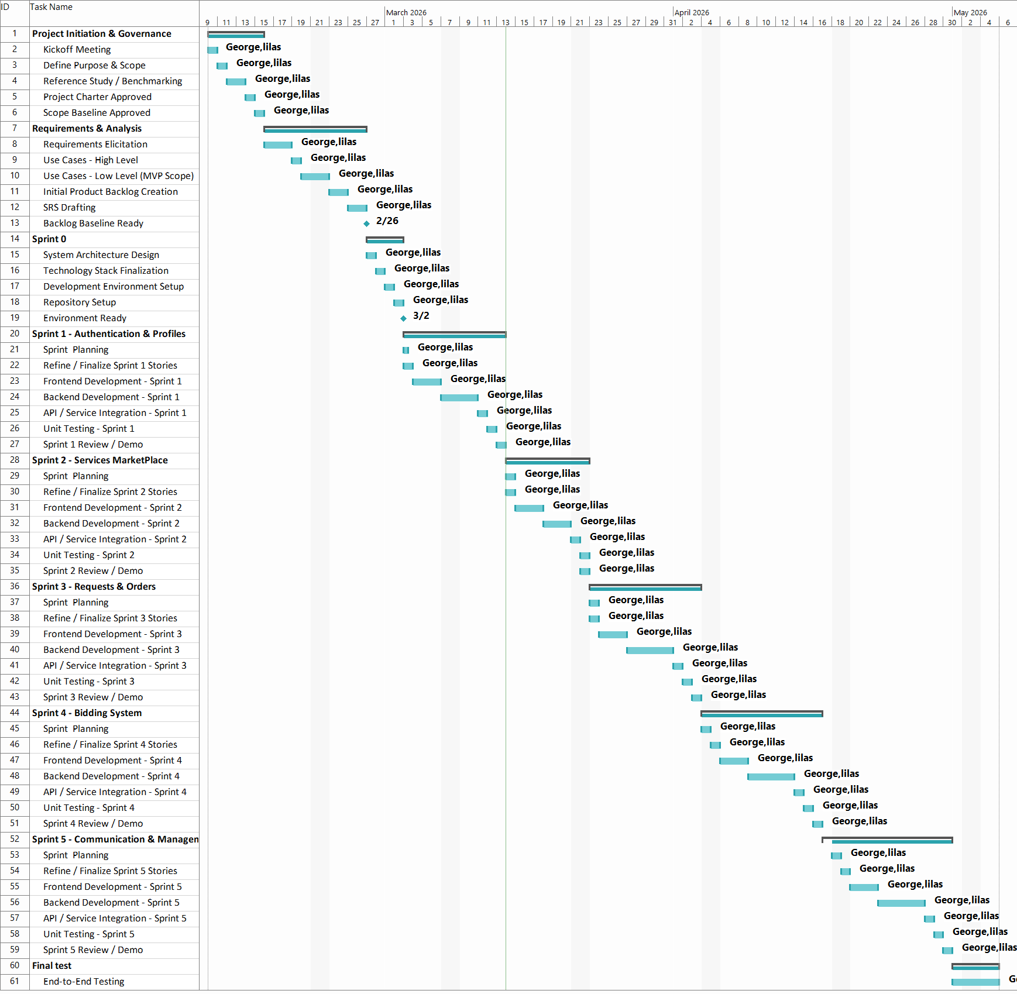 Figure 1 Gantt Chart

2.3 Risk Management
Risk management is an essential part of the development of Syrian Services Hub because the project includes multiple functional modules and an intelligent recommendation component within a limited academic timeframe. One of the main risks is requirements refinement during development, since some features may need adjustment as the system structure becomes clearer. Another important risk is implementation complexity, especially when integrating the recommendation feature with the rest of the platform in a way that remains meaningful and manageable. Time limitation is also a critical risk, as academic deadlines may restrict the depth of development, testing, and documentation. In addition, there is a risk related to consistency between analysis, design, and implementation, particularly in a project that includes many interacting roles and workflows. To reduce these risks, the project relies on phased development, continuous review of requirements and use cases, prioritization of core features, and structured documentation of decisions throughout the project lifecycle. This approach helps maintain control over progress while reducing confusion, rework, and scope drift.
table 1 Risk Register
Risk ID | Risk Description | Likelihood | Impact | Mitigation Strategy
R-01 | Requirements may change or become clearer during development. | Medium | High | Use iterative review, keep requirements traceable, and prioritize core features.
R-02 | Time limitations may reduce implementation or testing depth. | High | High | Apply phased work planning and focus first on must-have features.
R-03 | Recommendation functionality may become too complex. | Medium | Medium | Keep the first version focused on problem-based suggestions and provider matching.
R-04 | Inconsistency between requirements, design, and implementation. | Medium | High | Use RTM, use cases, and continuous documentation review.
R-05 | Data or diagram updates may affect documentation accuracy. | Medium | Medium | Review models and tables before final submission.
R-06 | Ask Assistant may retrieve insufficient, private, archived, or unrelated evidence. | Medium | High | Apply permission-first retrieval, restrict answers to active provider-owned sources, require citations, and return an insufficient-evidence response when grounding is weak.

2.4 Team Roles and Task Distribution
This project was developed within an academic software engineering context that required careful distribution of analysis, design, documentation, and implementation tasks. The work involved identifying system requirements, preparing use cases and supporting models, designing the overall platform structure, and organizing the project report according to academic standards. Since the project combines marketplace functionality with an intelligent recommendation feature, the task distribution had to address both the core service platform components and the smart system aspect. The overall workflow included requirements analysis, structural planning, feature definition, documentation preparation, and progressive refinement of the system’s functional scope. This organized division of work helped maintain clarity throughout the project and ensured that the development process remained aligned with both the technical objectives of the system and the formal requirements of the graduation project documentation.

2.5 Quality Management in the Project
Quality management in Syrian Services Hub is based on maintaining consistency, clarity, and reliability throughout the project lifecycle. Since the project includes multiple modules and interactions between different user roles, quality cannot be limited to implementation only, but must also be reflected in requirements definition, system organization, documentation accuracy, and logical coherence between analysis, design, and development. For this reason, the project emphasizes clear requirement specification, structured use case descriptions, organized system modeling, and continuous review of functional relationships between the platform components. Quality is also supported by maintaining alignment between the intended behavior of the system and the documented requirements, while reducing ambiguity and unnecessary complexity. In addition, the intelligent recommendation feature requires special attention to relevance and usability, so that it remains connected to the actual purpose of the platform rather than appearing as an isolated feature. Through this approach, quality management serves as a guiding principle for producing a system that is both academically well-documented and practically meaningful.

2.6 Project Management Tools Used
Project management in Syrian Services Hub relies on organized documentation, structured task follow-up, and controlled file management throughout the project lifecycle. Requirement tables, use case specifications, diagrams, and report sections are maintained in an organized manner to preserve consistency between analysis, design, and implementation. Version control practices are also important for managing development changes and reducing the risk of losing or overwriting work. This approach keeps the project manageable, improves coordination between technical and documentation activities, and supports the disciplined workflow expected in an academic software engineering project.

2.7 Monitoring and Continuous Evaluation Mechanisms
The development of Syrian Services Hub requires continuous monitoring and evaluation to ensure that the project remains aligned with its objectives and documented requirements. Because the platform includes multiple user roles, interconnected workflows, and an intelligent recommendation feature, periodic review is necessary to verify that the evolving system structure remains coherent and manageable. Continuous evaluation is reflected in revisiting requirements, reviewing use case consistency, checking the logical relationship between features, and ensuring that the documented analysis still matches the intended implementation. This process also supports early identification of gaps, inconsistencies, or unnecessary complexity before they affect later stages of the project. As a result, monitoring and continuous evaluation help maintain the overall quality of the project and improve confidence in both the technical structure and the academic documentation.

2.8 Software Configuration Management
Software Configuration Management in Syrian Services Hub is important for maintaining order, consistency, and traceability throughout the project lifecycle. Since the project evolves through multiple stages of analysis, design, implementation, and revision, configuration control helps preserve the integrity of project artifacts and reduces the risk of confusion between changing versions of files, models, and technical components. This includes maintaining organized documentation, preserving updated requirement and use case files, and ensuring that revisions to system-related materials remain clear and controlled. Configuration management also supports structured progress during development by reducing duplication, avoiding accidental loss of work, and helping keep the project aligned with its latest approved version. As a result, it contributes to both technical discipline and academic reliability in documenting and developing the system.

Section Two: Theoretical Study and Analysis

Chapter Three: Literature Review and Comparative Study
This chapter presents the theoretical and comparative foundation of Syrian Services Hub by reviewing related service marketplace platforms, identifying the main operational models used in the domain, and analyzing the functional patterns that influenced the proposed system. It also highlights the relevance of hybrid service marketplace structures, clarifies the reference value of existing platforms, and prepares the basis for later discussion of requirements, design decisions, and the distinctive contribution of the project.

3.1 Related Work in Smart and Similar Service Platforms
Syrian Services Hub is positioned within the broader domain of digital service marketplace platforms that connect service providers with consumers through structured online environments. In order to define the proposed system on a solid academic basis, it is necessary to examine existing reference platforms that already implement key service marketplace workflows in different forms. The benchmark study prepared for this project shows that the most relevant reference platforms include Khamsat, Mostaql, Fiverr, Upwork, Freelancer, and PeoplePerHour. These platforms collectively demonstrate two major operational patterns: ready-made service publishing and open service-request bidding. The study also indicates that mature platforms typically rely on a combination of user accounts, professional profiles, service management, request posting, offer submission, messaging, ratings, complaints handling, verification, and dashboard-based monitoring. Therefore, Syrian Services Hub is not treated as a copy of any single existing platform, but rather as a carefully synthesized system that draws justified functional decisions from multiple market-proven references while adapting them to its own local and academic context.

3.2 Modern Technologies and Frameworks in the Domain
Modern service marketplace platforms are increasingly shaped by web-based architectures, interactive user interfaces, scalable backend frameworks, and intelligent support features that improve discoverability and user experience. In this domain, frontend frameworks such as React are widely used to create responsive and component-based interfaces, while backend frameworks such as Django provide structured support for data-driven applications, role-based workflows, and API-oriented logic. Database systems such as PostgreSQL are also highly relevant in this context because they support reliable storage, structured relationships, and transactional consistency for platforms that involve users, services, offers, messages, complaints, and administrative records. In addition, supporting tools such as Postman are useful for testing communication between frontend and backend layers during development. From the intelligent systems perspective, recommendation-oriented functionality has become increasingly important in digital platforms because it helps users navigate large sets of options and identify more relevant results based on their stated needs or behavior. Therefore, the technical direction of Syrian Services Hub is consistent with contemporary platform development practices that combine modern web technologies with structured service workflows and intelligent support mechanisms.

3.3 Comparative Analysis of Existing Platforms
A comparative analysis of existing service marketplace platforms is essential for understanding how Syrian Services Hub should be positioned functionally and structurally. The benchmark study prepared for this project indicates that no single reference platform fully represents the complete intended scope of the proposed system. Instead, each platform contributes a different operational strength. Khamsat represents a clear reference for ready-made service publishing and simplified service browsing, while Mostaql provides a stronger model for open service requests and offer-based interaction between users and providers. Fiverr contributes a mature structure for presenting services in a clear and organized way, whereas Upwork demonstrates a hybrid model that combines direct service offerings, project-based requests, messaging, trust mechanisms, and verification processes. Freelancer provides useful reference logic for offer progression, provider activity, and dashboard-oriented tracking, while PeoplePerHour supports the idea that ready-made offers and custom project proposals can coexist within the same platform structure. Based on this comparison, Syrian Services Hub is designed as a hybrid service marketplace that integrates both service publishing and open service-demand advertisements within one coherent platform.

table 2Comparative Analysis of Reference Platforms
Platform | Dominant Model | Main Reference Components | Design Role in Syrian Services Hub
Khamsat | Ready-made services | Service, seller profile, ratings, messages | Reference for service listing, browsing, and trust indicators.
Mostaql | Open requests and offers | Project/request, offers, provider selection | Reference for service-demand advertisements and competitive offers.
Fiverr | Gigs / packaged services | Gig page, packages, add-ons | Reference for structured service presentation and clear scope.
Upwork | Hybrid marketplace | Project Catalog, proposals, direct messages, verification | Reference for combining service catalog, requests, messaging, and trust mechanisms.
Freelancer | Bidding and dashboards | Projects, bids, milestones, dashboards | Reference for offer status, provider activity, and dashboard tracking.
PeoplePerHour | Offers and custom projects | Offer, proposal, escrow logic | Reference for coexistence of ready-made offers and custom requests.

3.4 Research Gap and Proposed Innovation
Although existing service marketplace platforms provide mature workflows for service publishing, request posting, offer submission, and user interaction, the benchmark study shows that their strengths are often distributed across different systems rather than unified in a single locally adapted platform. Some platforms are stronger in ready-made service presentation, while others are more suitable for open request and bidding workflows. In addition, certain useful decision-support behaviors, such as comparing multiple providers before selecting one, are often present only implicitly through scattered indicators rather than through a dedicated and structured comparison feature. This creates a gap between the functional richness of the market and the practical clarity required by users, especially in a localized platform context. Syrian Services Hub addresses this gap by proposing a hybrid service marketplace that combines direct service publishing with open service-demand advertisements in one coherent system, while also strengthening user decision-making through recommendation-oriented support and explicit comparison possibilities. The proposed innovation of the project does not lie in inventing an entirely unfamiliar model, but in synthesizing proven service-marketplace patterns into a structured local platform and augmenting them with intelligent and decision-support features that improve accessibility, clarity, and usability.

3.5 Theoretical Background and Reference Foundations
The theoretical foundation of Syrian Services Hub is based on the concept of digital service marketplace systems, which are designed to organize interactions between service providers and consumers within a controlled online environment. Such systems do not only provide a communication channel between two parties, but also establish structured workflows for account creation, service publishing, request posting, offer submission, interaction management, trust building, and administrative supervision. From a systems analysis perspective, the project is also grounded in the idea of hybrid marketplace logic, where two complementary usage paths coexist within the same platform: direct access to ready-made services and open service-demand advertisements that invite competitive offers. In addition, the project draws on the theoretical value of intelligent support features, particularly recommendation-oriented behavior, which enhances user decision-making by helping identify more relevant solutions and providers based on stated needs. The benchmark study serves as the reference foundation of the project by connecting these theoretical concepts to real market examples, allowing the proposed system to be justified through established platform behavior rather than ungrounded assumptions. In this way, Syrian Services Hub is positioned as a structured, locally adapted, and academically supported service marketplace with both functional and intelligent dimensions.

3.6 Modern and Future Trends in the Domain
Digital service marketplace platforms are increasingly evolving beyond basic service listing and request exchange toward more intelligent, adaptive, and data-informed systems. One major trend in the domain is the integration of smart support features that improve how users discover relevant services and make decisions among multiple providers. Recommendation-oriented functionality, personalized result presentation, and decision-support mechanisms are becoming more important as platforms grow in size and complexity. Another important trend is the increasing reliance on modern web technologies that support responsive interfaces, dynamic interaction, and scalable backend processing, which together improve both usability and system maintainability. In addition, trust and platform governance continue to play a critical role in the development of service marketplaces, which explains the growing importance of verification, complaint handling, transparent ratings, and administrative control. From a future-oriented perspective, service platforms are expected to become more context-aware, more personalized, and more supportive of guided user interaction rather than simple browsing alone. Syrian Services Hub aligns with these trends by combining a hybrid service marketplace structure with intelligent recommendation support and organized trust-related mechanisms, which positions the project within the broader movement toward smarter and more user-centered digital platforms.

Chapter Four: Requirements Analysis and Modeling

3.7 Retrieval-Augmented Generation for Provider Question Answering
Retrieval-Augmented Generation combines information retrieval with generative language models. Instead of asking the model to answer from general model knowledge alone, the system searches a controlled knowledge collection, selects relevant evidence, and generates an answer constrained by the retrieved content. In customer-facing service platforms, this approach improves factual grounding, makes answers traceable through citations, and provides a safe path for returning an insufficient-evidence message when the available sources do not support a claim.
Syrian Services Hub applies this pattern through Ask Assistant. Provider-owned knowledge sources are ingested, divided into searchable chunks, transformed into vector embeddings, and stored with ownership and visibility metadata. At question time, the system applies permission filters before similarity retrieval, supplies the approved evidence to the answer-generation step, and stores citations with the assistant turn. This capability remains independent of AI Recommendation: recommendation assists service and provider selection, whereas RAG answers evidence-based questions about a provider or service.
This chapter defines the functional and non-functional requirements of Syrian Services Hub and explains how the system is analyzed and modeled from a software engineering perspective. It identifies the main stakeholders, clarifies their needs, and presents the core system requirements in a structured form. The chapter also includes requirement prioritization, UML modeling, incremental requirement organization, traceability, and initial test cases. Special attention is given to the recommendation feature, where the user enters a problem description and the system returns suggested solutions and a suitable service provider.
Ask Assistant requirements are documented independently from the AI Recommendation requirement. The recommendation capability produces suitable service directions and provider suggestions, while Ask Assistant retrieves authorized knowledge and returns grounded answers with citations.

4.1 Feasibility Study
The feasibility of Syrian Services Hub can be examined from technical, practical, and academic perspectives. Technically, the project is feasible because its core functionality can be implemented using modern web development technologies that support role-based interaction, database-driven workflows, and structured service operations. The main system functions, including account management, service publishing, service requests, offers, messaging, ratings, complaints, verification, dashboards, and recommendation support, are all within the scope of standard web application development. Practically, the project addresses a realistic need for a local service marketplace where users and providers can interact in a more organized and transparent environment. Academically, the project is suitable because its requirements, workflows, and intelligent component can be analyzed, modeled, designed, and tested according to software engineering principles.

4.2 Requirements Gathering
The requirements of Syrian Services Hub were gathered through a structured analytical process based on the project idea, the intended platform roles, the expected service marketplace workflows, and the benchmark study prepared for the project. The process focused on identifying what the system must support for visitors, registered users, service providers, and administrators. It also considered the behavior of existing marketplace platforms in order to justify the proposed requirements academically. As a result, the requirements cover account management, professional profiles, services, service-demand advertisements, offers, messaging, ratings, complaints, verification, dashboards, provider comparison, and recommendation support.

4.3 Stakeholders and Needs Analysis
The main stakeholders in Syrian Services Hub include visitors, registered users, service providers, and administrators. Each stakeholder interacts with the system from a different perspective and has specific needs that must be reflected in the requirements. The following table summarizes these stakeholders and their main expectations.
table 3 Stakeholders and Needs Analysis
Stakeholder | Main Needs | System Support
Visitor | Browse services before registration and understand available providers. | Public service browsing and basic service/provider information.
Registered User | Request services, post service-demand advertisements, receive offers, compare providers, and get recommendations. | Service request workflow, offer review, messaging, ratings, and recommendation page.
Service Provider | Publish services, manage profile, submit offers, communicate with users, and monitor activity. | Provider profile, service management, offer management, chat, dashboard, and verification request.
Administrator | Control the platform, manage users, review complaints, approve or revoke verification, and monitor statistics. | Admin dashboard, complaint management, verification management, and account control.
Registered User - Ask Assistant | Ask factual questions about a selected provider or service and understand the evidence behind the answer. | Authenticated question submission, grounded answer, source citations, and conversation history.
Service Provider - Knowledge Sources | Upload, list, archive, and reindex customer-facing knowledge sources while controlling what customers may retrieve. | Knowledge-source management, ingestion status, visibility control, and reindex operations.
Administrator - RAG Oversight | Review failed ingestion, restricted content, and misuse without bypassing provider ownership rules. | Administrative review of knowledge status, audit data, and customer-assistant activity.

4.4 Functional Requirements
The functional requirements define the core behaviors that Syrian Services Hub must provide. They represent the main system capabilities required to support both direct service browsing and open service-request workflows. The table below summarizes the key functional requirement groups used in the project. The recommendation requirement and the ability of the administrator to revoke provider verification are included explicitly to keep the requirements aligned with the current system scope.

table 4 Functional Requirements

Requirement ID | Title | Type | Priority | Owner | Description | Acceptance Criteria
AUTH-001 | Create User Account | Functional | High | Visitor | Allows a visitor to create a new user account by entering name, email, and password. | A new record is created in the Users table, and the email address and phone number must be unique.
AUTH-002 | Create Service Provider Account | Functional | High | Visitor | Allows a visitor to register as a service provider by entering name, email, password, and category. | An account with the service provider role is created, and a linked service provider profile is created.
AUTH-003 | Login | Functional | High | User / Provider / Admin | Allows a user, service provider, or admin to log in using email and password. | The credentials are validated, and a valid login session is created.
AUTH-004 | Logout | Functional | Medium | User / Provider / Admin | Allows a user, service provider, or admin to log out of the system. | The current user session is ended.
AUTH-005 | Change Password | Functional | High | User / Provider | Allows a user or service provider to change the password after entering the current password and the new password. | The password is updated in the database after verifying the current password.
PROF-001 | Edit Personal Information | Functional | High | User / Provider | Allows the user to edit personal information such as name, email, phone number, and location. | The user data is successfully updated in the database.
PROV-002 | Edit Service Provider Information | Functional | High | Provider | Allows the service provider to edit professional information such as skills, description, and location. | The service provider data is updated in the Service Providers table.
PROV-003 | View Service Providers | Functional | High | User / Visitor | Allows the user to browse the list of registered service providers and view basic information such as name, rating, and provided services. | Service provider data is retrieved from the database and displayed to the user.
PROV-004 | Compare Service Providers | Functional | Medium | User | Allows the user to select multiple service providers and compare information such as price, rating, execution time, and number of provided services. | A comparison table is displayed containing the selected service providers' information.
SERV-001 | Add Service | Functional | High | Provider | Allows the service provider to add a new service including service name, description, price, and execution duration. | A new service record linked to the service provider is created.
SERV-002 | Edit Service | Functional | High | Provider | Allows the service provider to edit the data of a service that belongs to them. | The service data is updated in the database.
SERV-003 | Delete Service | Functional | High | Provider | Allows the service provider to delete a service they added. | The service is deleted or deactivated in the database.
SERV-004 | View Services | Functional | High | User / Visitor | Allows users to browse the available services on the platform. | Services are retrieved from the database and displayed to the user.
SERV-005 | Search for a Service | Functional | High | User / Visitor | Allows the user to search for services using keywords. | Services matching the search query are displayed.
SERV-006 | Filter Services | Functional | High | User / Visitor | Allows the user to filter services by price, rating, or verified accounts. | Services matching the filter criteria are displayed.
RECO-001 | Recommendation | Functional | High | System / User | Allows the system to provide helpful advice to users and recommend suitable service providers based on the selected service category, request description, provider skills, ratings, location, and service information. | The system displays useful advice and a list of suitable service providers related to the user's request or selected service category.
SERV-007 | Send Request for an Existing Service | Functional | High | User | Allows the user to submit a request for an existing service that was previously added by a service provider. | A new request record is created in the database and linked to the user, service, and service provider, with the status set to Pending.
SERV-008 | Send Offer on Service Request | Functional | High | Provider | Allows the service provider to respond to a service request sent by the user by sending an offer that includes price, duration, or execution details. | A new offer record linked to the service request is created, and the request status is updated to indicate that an offer has been sent.
SERV-009 | Reject Service Request | Functional | High | Provider | Allows the service provider to reject a service request sent by the user. | The request status is updated in the database to Rejected.
SERV-010 | Complete Service | Functional | High | Provider | Allows the service provider to complete the service after finishing its execution for the user. | The service or request status is updated in the database to Completed or Finished successfully.
ORDER-001 | Track Service Request Status | Functional | High | User | Allows the user to track the status of service requests sent to service providers to know whether they are still pending, rejected, or answered with an offer. | The status of each service request is displayed correctly, such as Pending, Rejected, or Offer Sent, and the data is retrieved from the database correctly.
BID-001 | Post New Service Request | Functional | High | User | Allows the user to publish a service request with a service description and expected budget. | A new service request record is created in the database.
BID-002 | Submit Offer on Request Post | Functional | High | Provider | Allows the service provider to submit an offer on the service request post sent by the user. | A new offer record linked to the service request post is created and contains the offer data sent by the service provider.
BID-003 | Edit Offer | Functional | Medium | Provider | Allows the service provider to edit an offer they previously submitted. | The offer data is updated in the database.
BID-004 | Delete Offer | Functional | Medium | Provider | Allows the service provider to delete an offer they submitted. | The offer is deleted or deactivated in the database.
BID-005 | Accept or Reject Offer | Functional | High | User | Allows the user to review the offer sent by the service provider and then accept or reject it. | The selected offer status is updated to Accepted or Rejected according to the user's action.
BID-006 | Track Offer Status | Functional | High | Provider | Allows the service provider to track the status of an offer they sent to know whether it was accepted, rejected, or is still waiting for the user's response. | The status of each offer is displayed correctly for the service provider, such as Pending, Accepted, or Rejected.
BID-007 | Edit Service Request Post | Functional | Medium | User | Allows the user to edit a service request post they previously published before selecting a final offer. | The service request post data is successfully updated in the database.
BID-008 | Delete Service Request Post | Functional | Medium | User | Allows the user to delete a service request post they previously published. | The service request post is deleted or deactivated in the database.
CHAT-001 | Create Conversation | Functional | High | System | The system creates a conversation between the user and the service provider when cooperation starts between them. | A new conversation record is created in the database.
CHAT-002 | Send Message | Functional | High | User / Provider | Allows the user or service provider to send a message within the conversation. | The message is saved in the Messages table.
REV-001 | Rate Service | Functional | High | User | Allows the user to rate the service after completing the request. | A new rating record is created in the database.
REV-002 | Add Comment within Rating | Functional | High | User | Allows the user to add a comment or text note within the rating after completing the service. | The comment is saved successfully with the rating record in the database.
REV-003 | View Rating Comments | Functional | Medium | User / Provider | Allows the system to display comments linked to ratings on the ratings page or in the service provider profile. | Comments linked to ratings are retrieved from the database and displayed correctly.
COMP-001 | Submit Complaint | Functional | High | User | Allows the user to submit a complaint against a service provider. | A complaint record is created with the status Open.
COMP-002 | Manage Complaints | Functional | High | Admin | Allows the admin to review complaints and change their status. | The complaint status can be changed to Under Review, Rejected, or Closed.
VER-001 | Request Service Provider Verification | Functional | High | Provider | Allows the service provider to submit a request to verify their account. | A new verification request is created with the status Pending.
VER-002 | Accept or Reject Verification Request | Functional | High | Admin | Allows the admin to review verification requests and accept or reject them. | The verification request status is updated in the database.
ADMIN-001 | Block and Unblock Accounts | Functional | High | Admin | Allows the admin to block or unblock user and service provider accounts when needed. | The account status is updated in the database to Blocked or Active according to the admin's action.
DASH-P-001 | Service Provider Dashboard | Functional | High | Provider | The dashboard displays information about the service provider's activity, such as completed tasks, average rating, offers, and earnings. | Statistical data is displayed from the database.
DASH-P-002 | Service Provider Earnings Dashboard | Functional | High | Provider | The service provider dashboard displays detailed earnings information, including total earnings, current month earnings, a monthly earnings chart, and average earnings per service. | Total earnings and current month earnings are displayed correctly, a monthly earnings chart is shown, and average earnings per service are calculated and displayed in the dashboard.
DASH-A-001 | Admin Dashboard | Functional | High | Admin | The dashboard displays general platform statistics such as number of users and number of requests. | Data is displayed from the database.
DASH-A-002 | Admin Analytics Dashboard | Functional | High | Admin | The admin dashboard displays platform activity analytics and statistics such as average offer value, offer acceptance rate, most requested category, total number of submitted offers, request distribution by category, and offer status distribution. | Average offer value, offer acceptance rate, and most requested category are displayed correctly, and charts show offer totals, request distribution by category, and offer status distribution.
UI-001 | Multilingual Support | Non-Functional | Medium | System | The system supports Arabic and English languages in the user interface. | The user can change the interface language, and the text is updated across all system pages.
UI-002 | Dark and Light Mode | Non-Functional | Medium | System | Allows the user to switch between dark mode and light mode in the interface. | The selected theme is applied to all system pages and the user's choice is saved.
NFR-001 | Performance and Response Speed | Non-Functional | High | System | The system must respond quickly to user actions while browsing services, searching, sending requests, and submitting offers. | The response time for basic operations must not exceed 3 seconds under normal conditions.
NFR-002 | Availability | Non-Functional | High | System | The system must be available to users, service providers, and admins most of the time without interruption. | The system must achieve at least 99% availability during the operating period.
NFR-003 | Security | Non-Functional | High | System | The system must protect user data, passwords, and sessions from unauthorized access. | Passwords are encrypted, access permissions are verified, and unauthorized access to pages and data is prevented.
NFR-004 | Usability | Non-Functional | Medium | System | The system interfaces must be clear and easy to use for all types of users. | The user can perform basic operations such as registration, search, and sending requests without needing additional explanation.
NFR-005 | Scalability | Non-Functional | Medium | System | The system must support an increase in the number of users, services, and requests without major performance degradation. | The system can handle a noticeable increase in users and requests while maintaining acceptable performance.
NFR-006 | Compatibility with Different Devices | Non-Functional | Medium | System | The system must work correctly on desktops, mobile phones, and tablets. | System pages are displayed correctly on different screen sizes.
RAG-001 | Ask Assistant | Functional | High | User / System | Allows an authenticated user to ask a factual question about a selected provider or service. The system retrieves relevant evidence only from active, authorized provider-owned knowledge sources and generates a grounded answer. | The system displays an answer with source citations when evidence is sufficient. If evidence is insufficient, it returns a clear insufficient-evidence response and does not invent facts.
RAG-002 | Manage Knowledge Sources | Functional | High | Provider / Admin | Allows a provider to upload, list, archive, and reindex customer-facing knowledge sources, while authorized administration can review ingestion status and restricted records. | Source ownership, visibility, ingestion status, and indexing state are stored. Private or archived sources are excluded from customer retrieval.

4.5 Non-Functional Requirements
The non-functional requirements define the quality attributes that the platform must maintain. They support usability, security, performance, availability, scalability, and compatibility across different devices. These requirements guide later design and testing decisions.
table 5 Non-Functional Requirements
Req. ID | Quality Attribute | Priority | Requirement Description | Acceptance Criteria
NFR-001 | Performance | High | The system should respond efficiently during browsing, searching, requesting, and offer submission. | Core operations should respond within an acceptable time under normal conditions.
NFR-002 | Availability | High | The platform should remain available for users, providers, and administrators most of the time. | The system should be accessible during normal operation with minimal interruption.
NFR-003 | Security | High | The system should protect accounts, sessions, passwords, and role-based access. | Passwords are protected, unauthorized access is blocked, and sensitive pages require permission.
NFR-004 | Usability | Medium | The platform should be clear and easy to use for all user roles. | Users can complete essential operations without unnecessary complexity.
NFR-005 | Scalability | Medium | The system should support growth in users, services, requests, and offers. | The design supports additional records and future feature expansion.
NFR-006 | Compatibility | Medium | The interface should work correctly on different screen sizes and devices. | Pages remain readable and usable on desktop, tablet, and mobile screens.
NFR-007 | Groundedness and Privacy | High | Ask Assistant must answer only from authorized active evidence, preserve provider ownership and visibility rules, cite supporting sources, and resist instructions contained inside retrieved documents. | Every supported factual answer includes citations; private, archived, or unrelated sources are excluded; and unsupported questions produce an insufficient-evidence response.

4.6 Requirements Prioritization and Management
The project requirements are prioritized to distinguish the core marketplace functions from supporting and value-adding functions. The MoSCoW method is used to organize requirements into Must Have, Should Have, Could Have, and Won’t Have for the current scope. This helps maintain implementation focus and reduces the risk of unnecessary scope expansion.
table 6 Requirements Prioritization
Priority | Included Requirements | Reason
Must Have | Authentication, service management, service requests, offers, messaging, complaint handling, verification, recommendation feature. | These requirements form the operational core of the platform.
Should Have | Ratings, comments, dashboards, provider comparison, search and filtering improvements. | They improve trust, decision-making, and user experience.
Could Have | Advanced analytics, expanded recommendation criteria, automated moderation, notification enhancements. | They add value but can be implemented progressively.
Won’t Have Now | Online payment integration, mobile application, advanced AI chatbot, external platform integration. | They are outside the current academic project scope.
Must Have | Ask Assistant (RAG), provider knowledge-source management, permission-aware retrieval, answer citations, and insufficient-evidence handling. | These requirements are necessary for safe, traceable, evidence-based customer question answering.

4.7 UML Requirements Modeling
UML requirements modeling provides a visual representation of the system’s main behaviors and interactions. Since Syrian Services Hub includes several actors and interconnected workflows, UML models are necessary to clarify how users, providers, visitors, and administrators interact with the system. The most important UML artifacts in this chapter include use case diagrams, use case descriptions, activity diagrams, and sequence diagrams.

4.7.1 Main Use Case Diagrams
The main use case diagram should present the primary actors and the most important system interactions. It should focus on the functional core instead of listing every minor operation. For this project, the diagram should include Visitor, User, Service Provider, and Administrator as the main actors. The key use cases should include browsing services, posting a service request, submitting an offer, accepting or rejecting an offer, managing services, managing complaints, managing verification, revoking verification, and getting problem-based recommendations.
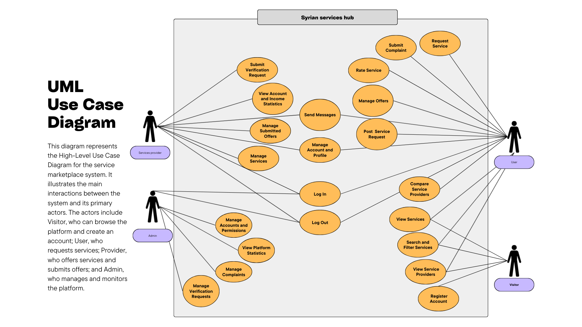Figure 2 Main Use Case Diagram for Syrian Services Hub
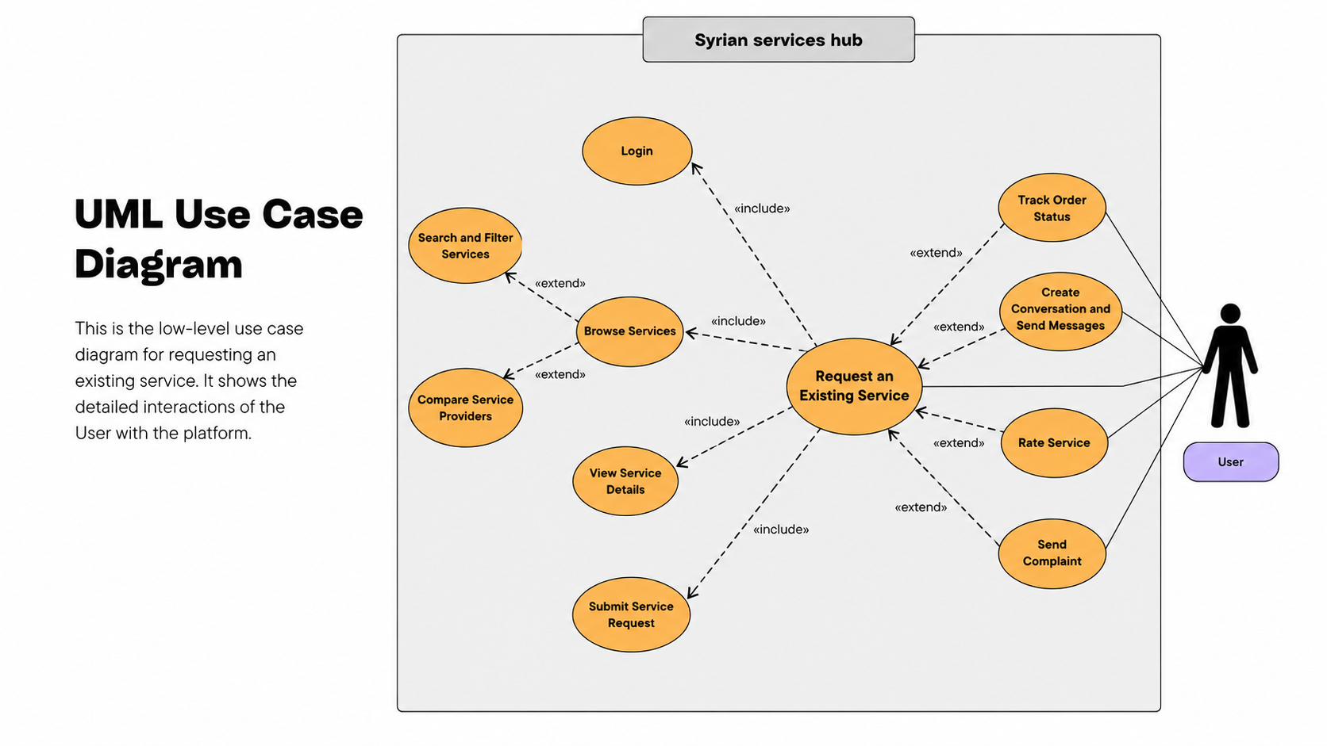
Figure 3 use cae request an exasting service
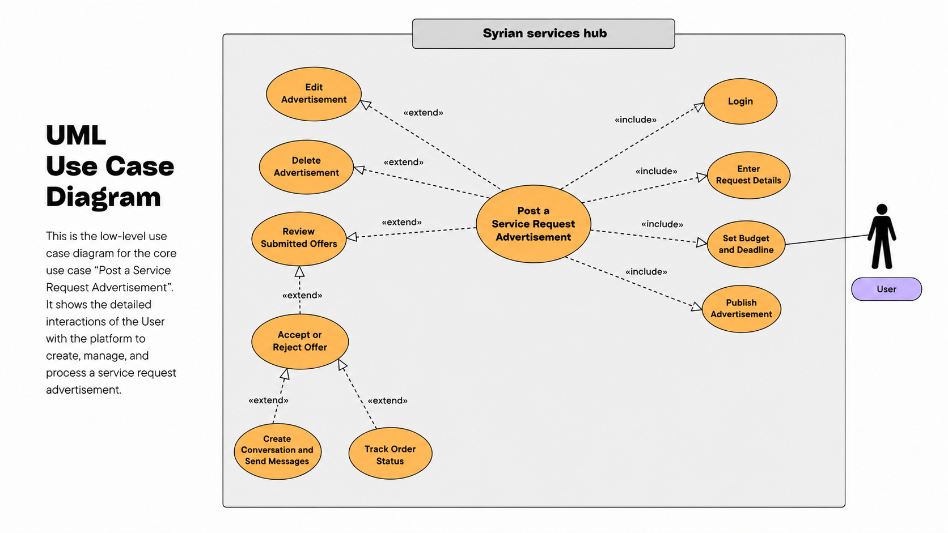
Figure 4 use cae post new request
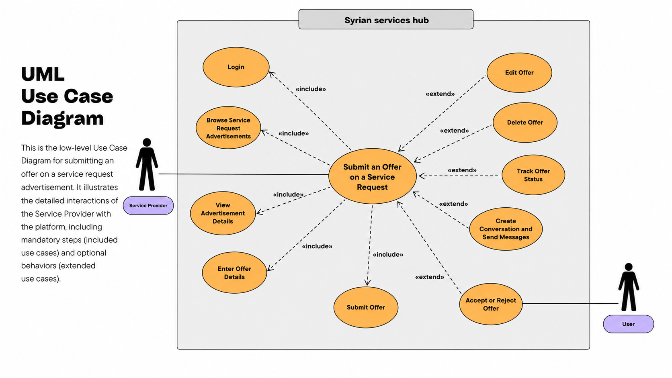
Figure 5 use case submite an offer

4.7.2 Use Case Descriptions
Use case descriptions explain the most important interactions in a structured textual form. Each description identifies the actor, objective, preconditions, main flow, exceptional flow, and postconditions. The table below summarizes the main use cases selected for the analysis chapter.
table 7 Use Case Descriptions- Submit Complaint
Field | Description
Use Case ID | COMP-001
Use Case Name | Submit Complaint
Actors | User
Goal | Enable the user to submit a complaint against a service provider.
Preconditions | 1. The user is logged in. 2. There has been a previous interaction with the service provider.
Main Flow | 1. System: Displays the “Submit Complaint” option and the complaint form. 2. User: Enters the complaint details and clicks “Submit”. 3. System: Verifies that the complaint is not empty, then creates a new complaint record with the status “Open”. 4. User: Returns to the previous page or the complaints page. 5. System: Displays the new complaint status and shows a success message.
Exceptional Flows | EF1: The complaint details are empty or invalid.
Postconditions | A complaint record is created with the status “Open”.
table 8 Use Case Descriptions accept or reject offer
Field | Description
Use Case ID | BID-005
Use Case Name | Accept or Reject Offer
Actors | User
Goal | Enable the user to review the offer submitted by the service provider and then accept or reject it.
Preconditions | 1. The user is logged in. 2. There is an offer submitted on a request or announcement that belongs to the user.
Main Flow | 1. System: Displays the list of offers received on the user’s requests or announcements. 2. User: Reviews a specific offer and clicks “Accept” or “Reject”. 3. System: Updates the status of the selected offer according to the user’s action. 4. User: Returns to the offers list or opens the offer details. 5. System: Displays the updated offer status and shows a success message.
Exceptional Flows | EF1: The offer has already been processed or is no longer available.
Postconditions | The offer status is updated to “Accepted” or “Rejected”.
table 9 Use Case Descriptions submit offer on request
Field | Description
Use Case ID | UC-22
Use Case Name | Submit Offer on Request
Actors | Provider
Goal | Enable the service provider to submit an offer on a service request posted by the user.
Preconditions | 1. The service provider is logged in. 2. There is an available service request that can receive offers.
Main Flow | 1. System: Displays the list of available service requests. 2. Provider: Selects a request, enters the offer details, and clicks the “Submit Offer” button. 3. System: Validates the entered data and creates a new offer record linked to the service request. 4. Provider: Moves to the provider’s offers list. 5. System: Displays the new offer and shows a success message.
Exceptional Flows | EF1: The request is not available, or the offer data is invalid.
Postconditions | A new offer record is created and linked to the service request.
table 10 Use Case Descriptions add services
Field | Description
Use Case ID | SERV-001
Use Case Name | Add Service
Actors | Provider
Goal | Enable the service provider to add a new service.
Preconditions | 1. The service provider is logged in. 2. The Add Service page is available.
Main Flow | 1. System: Displays the Add Service form, including name, description, price, and execution duration. 2. Provider: Enters the service details and clicks the “Save” button. 3. System: Validates that all required data is completed and that the price and execution duration are valid. 4. Provider: Confirms the operation. 5. System: Creates a new service record linked to the provider and displays a success message.
Exceptional Flows | EF1: The data is incomplete, or the price/execution duration is invalid.
Postconditions | A new service record is created and linked to the service provider.
table 11 Use Case Descriptions post new request
Field | Description
Use Case ID | UC-21
Use Case Name | Post New Request
Actors | User
Goal | Enable the user to post a service request announcement with a service description and expected budget.
Preconditions | 1. The user is logged in. 2. The Post New Request page is available.
Main Flow | 1. System: Displays the Post New Request form. 2. User: Enters the service description and expected budget, then clicks the “Post Request” button. 3. System: Validates that the data is complete and that the budget is valid, then creates a new service request record. 4. User: Moves to the user’s requests page or continues browsing. 5. System: Displays the new request in the user’s request list and shows a success message.
Exceptional Flows | EF1: The budget or entered data is invalid.
Postconditions | A new service request record is created in the database.

4.7.3 Activity Diagrams
Activity diagrams describe the workflow of major processes step by step. They are useful for representing decisions, validations, and outcomes in operations that include multiple stages. In this project, the recommended activity diagrams are related to posting a service request, submitting an offer, accepting or rejecting an offer, and getting recommendations from the recommendation page.
For Ask Assistant, the activity flow begins with authentication and provider selection, continues through permission-aware retrieval and evidence scoring, and ends with either a cited answer or an insufficient-evidence response. A corresponding sequence view should show the interaction between the user interface, customer-assistant API, retrieval service, vector-enabled data layer, OpenAI service, and citation persistence.
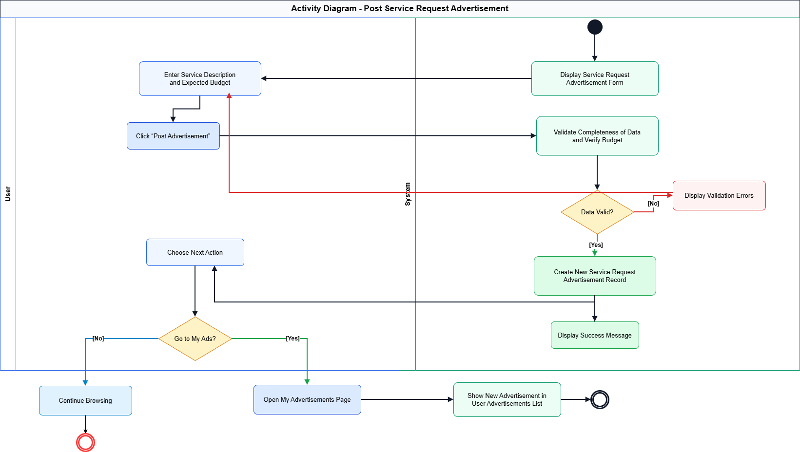Figure 6 Post Service Request

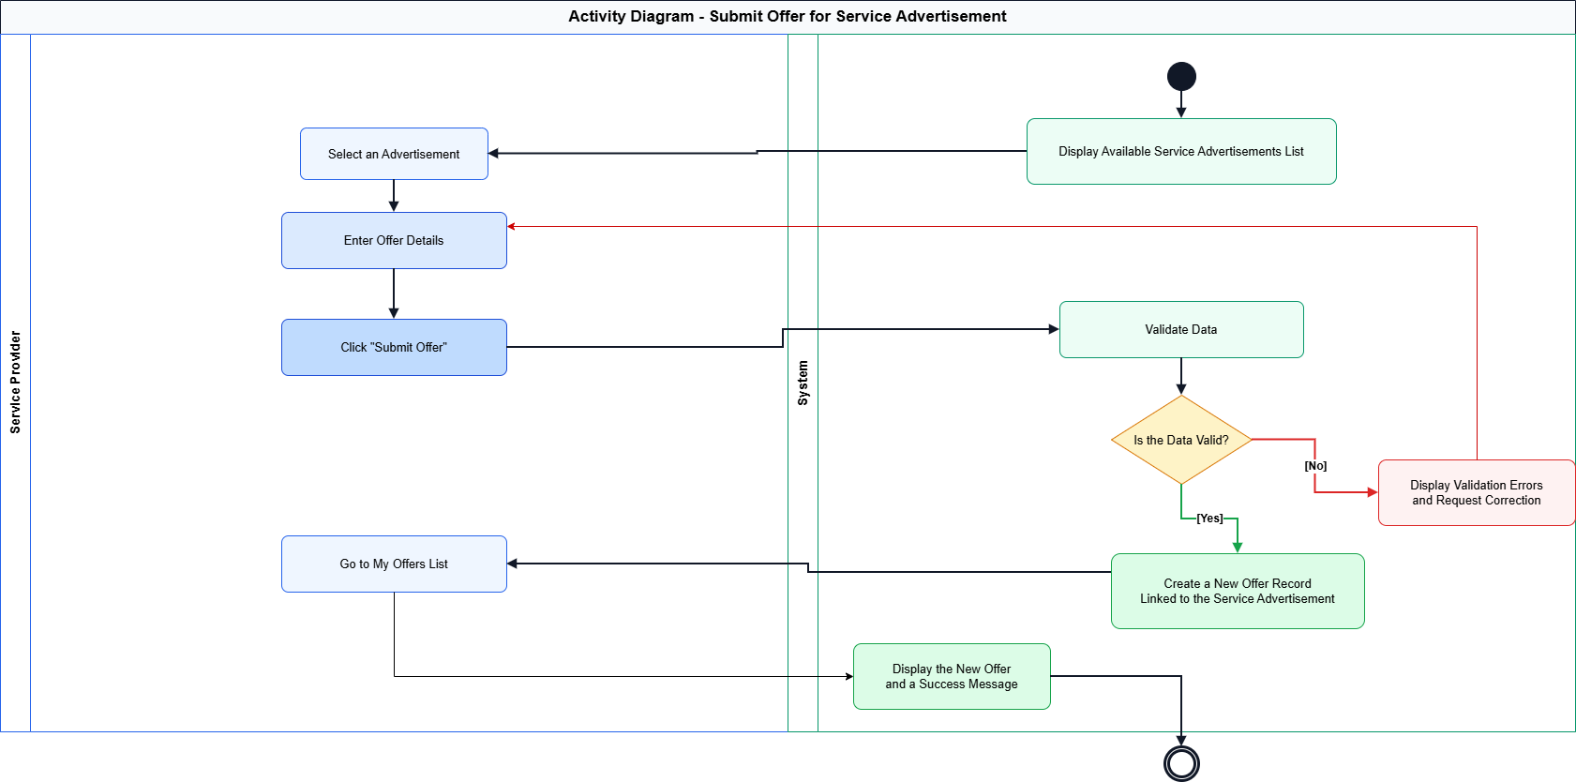Figure 7 Activity Diagram - Submit Offer
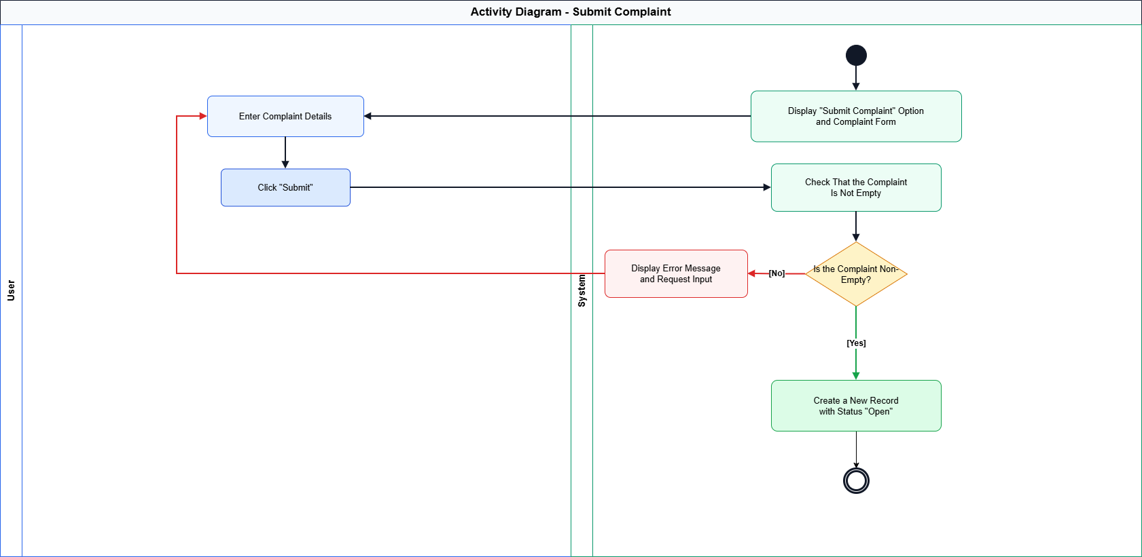
Figure 8 Activity Diagram submit compliant

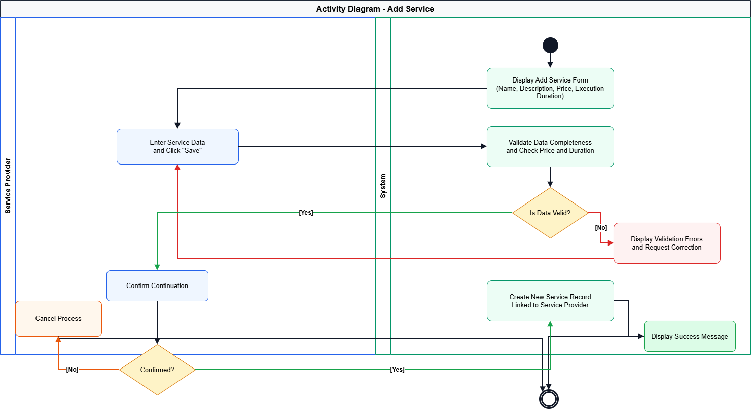
Figure 9 Activity Diagram add services

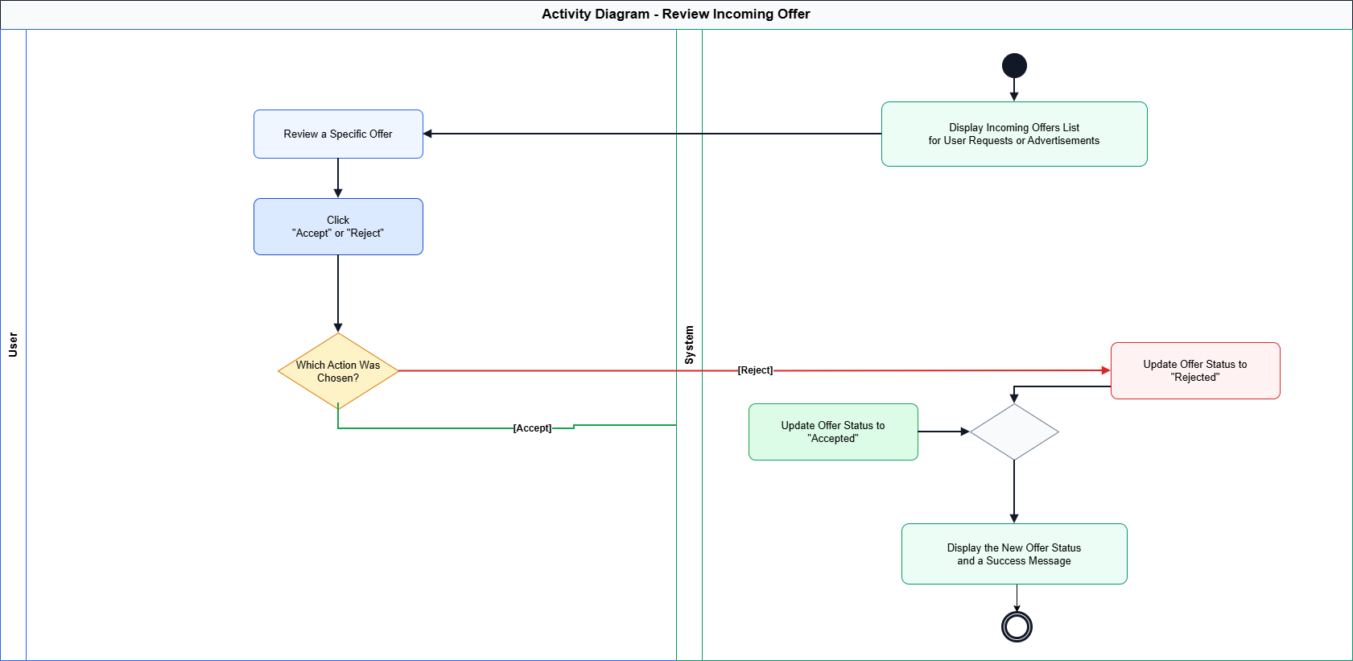
Figure 10 Activity Diagram review incoming offer

4.7.4 Sequence Diagrams
Sequence diagrams show the chronological interaction between actors and system components during the execution of major use cases. They are especially useful for clarifying how requests move between the user interface, the application logic, and the database layer. The following placeholders should be replaced with the final sequence diagrams.
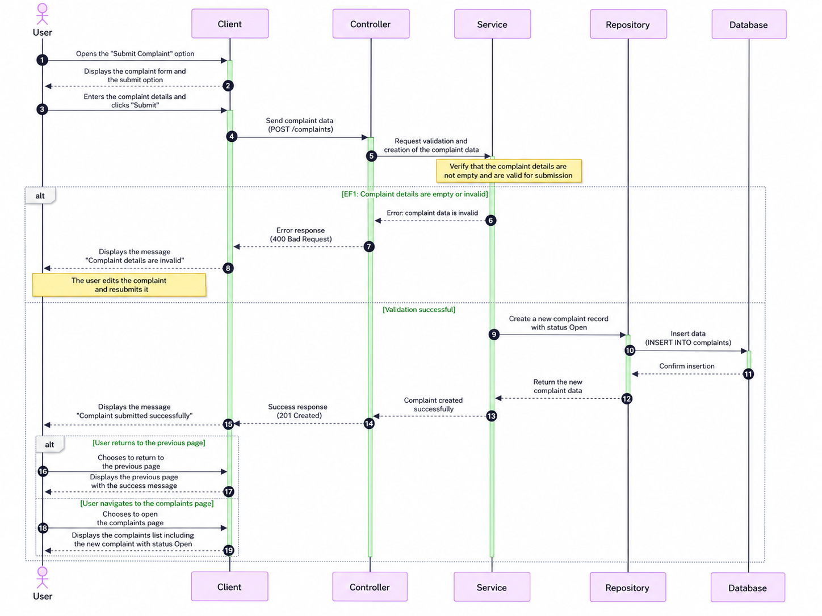
Figure 11 Sequence Diagram - Submit Offer
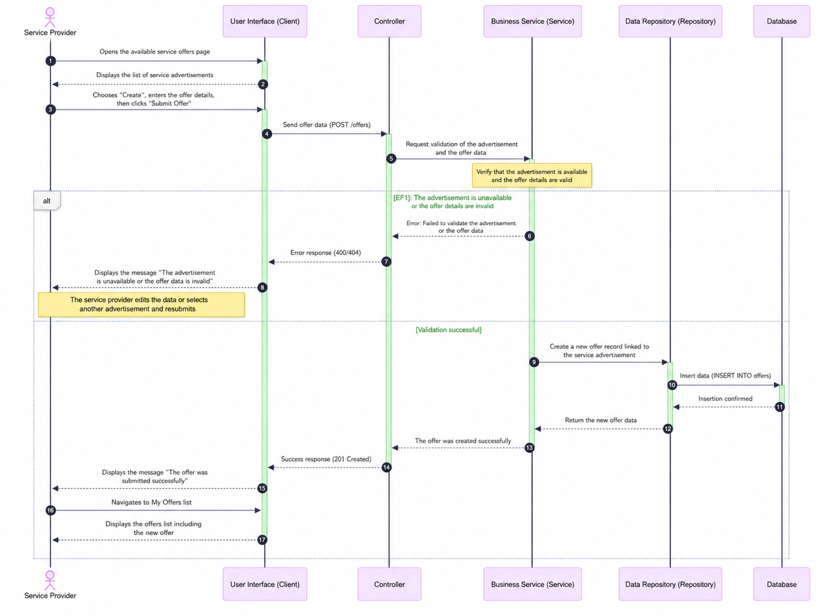
Figure 12 Sequence Diagram - Submit Offer
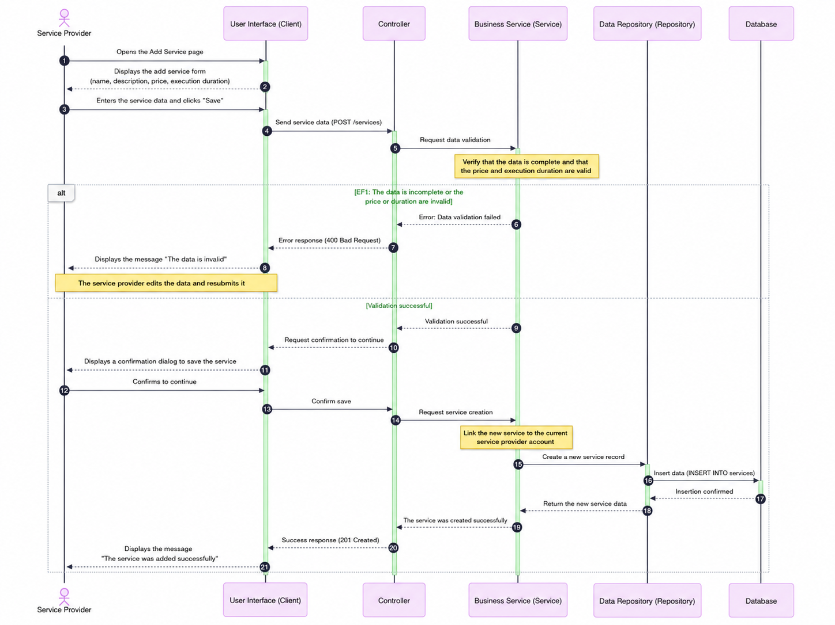
Figure 13 Sequence Diagram - add services
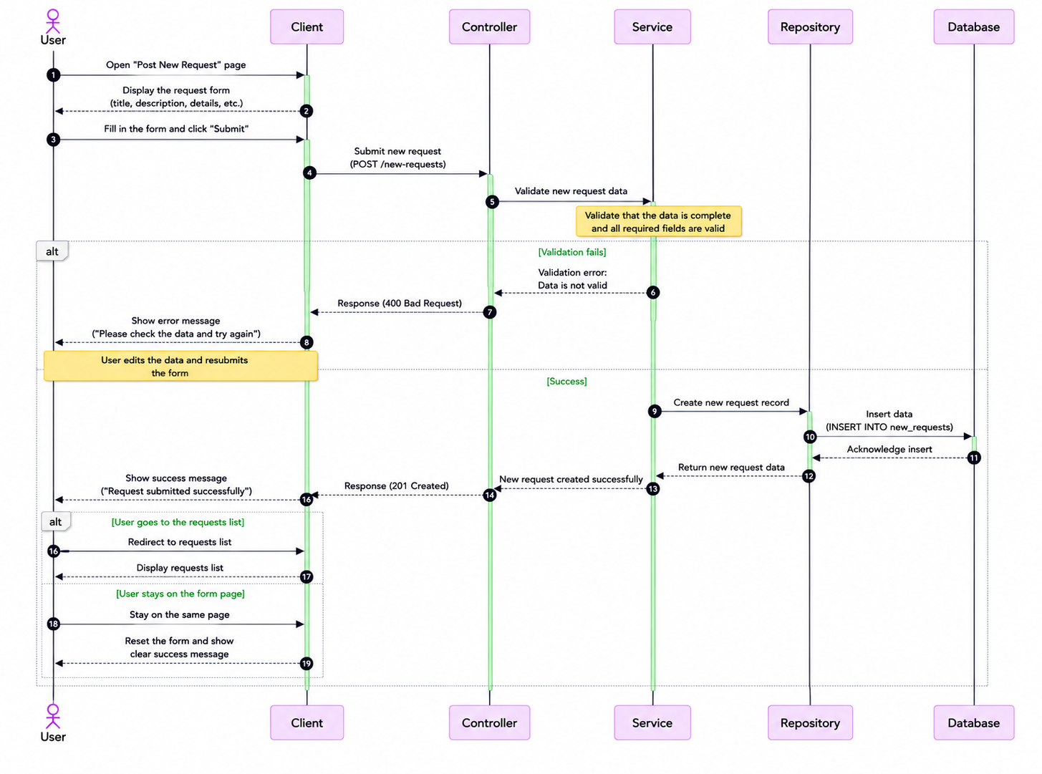
Figure 14 Sequence Diagram -post new request

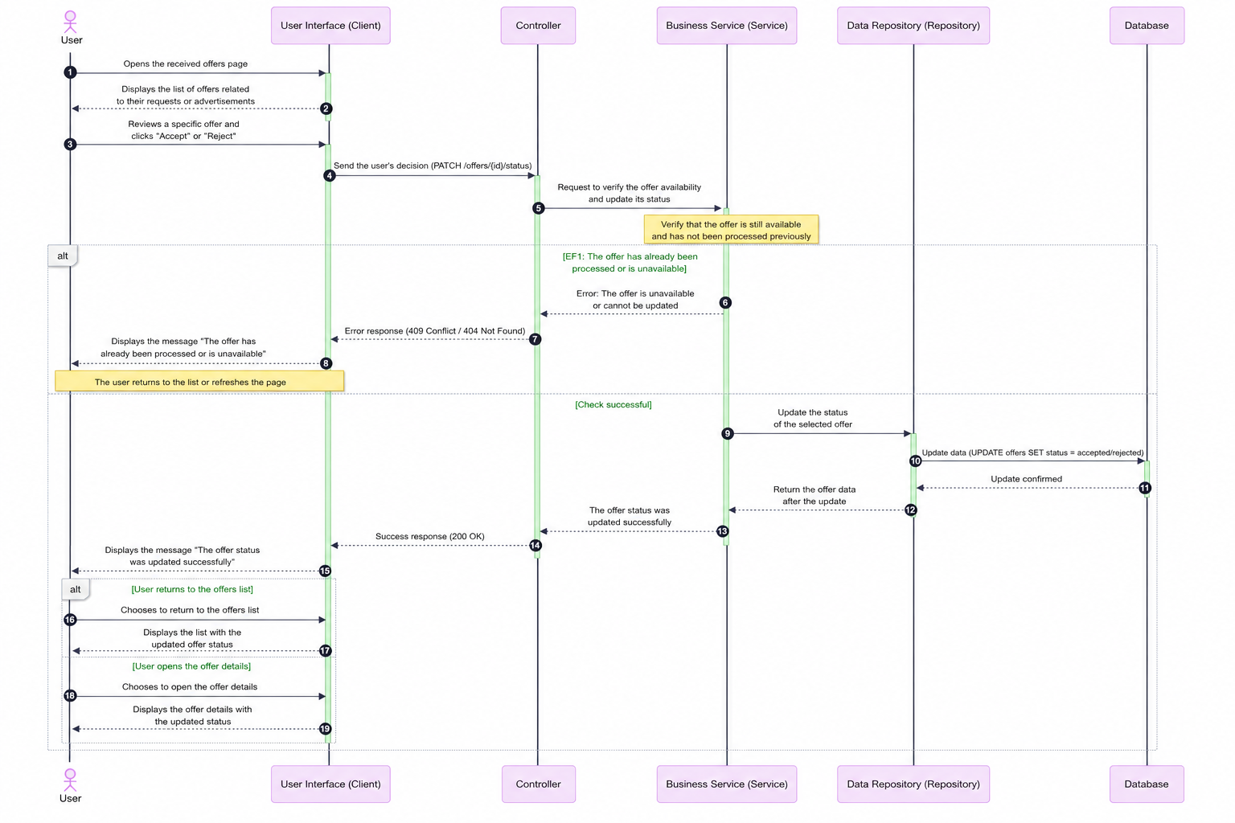

Figure 15 Sequence Diagram -review incoming offer
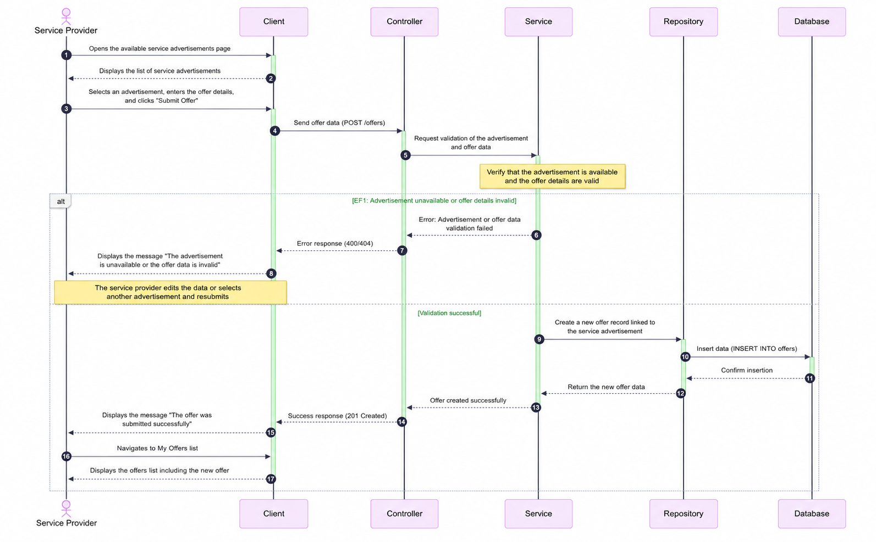
Figure 16 : Sequence Diagram submit complaint

4.8 Modeling According to the Selected Methodology
Since Syrian Services Hub uses Incremental Development, the requirements are organized into prioritized increments that deliver usable capabilities progressively. The supporting artifacts include user stories, an increment plan, acceptance criteria, dependency awareness, and review outputs for each completed increment. This form of modeling complements UML diagrams by showing how requirements are grouped into coherent deliveries, validated after implementation, and extended in later increments without losing traceability.

4.8.1 Increment Plan and User Stories
table 12 Increment Plan and User Stories
Story ID | User Story | Priority | Acceptance Focus
US-01 | As a visitor, I want to browse services so that I can explore the platform before registering. | Must | Services are displayed without requiring login.
US-02 | As a user, I want to post a service request so that providers can submit offers. | Must | A request is created and visible to eligible providers.
US-03 | As a provider, I want to publish services so that users can request them directly. | Must | A service is created and linked to the provider profile.
US-04 | As a provider, I want to submit offers on user requests so that I can compete for work. | Must | An offer is saved and linked to the selected request.
US-05 | As a user, I want to compare providers so that I can select the most suitable one. | Should | Provider data is displayed in a comparison view.
US-06 | As a user, I want to enter a problem and receive suggested solutions and a provider. | Must | The system displays solution suggestions and a recommended provider.
US-07 | As an admin, I want to revoke provider verification so that trust violations can be handled. | Must | The provider verification status changes to unverified and the action is logged.
US-08 | As an authenticated user, I want to ask a factual question about a selected provider or service so that I can receive a grounded answer with source citations. | Must | Ask Assistant returns a cited answer from authorized evidence or a clear insufficient-evidence response.
US-09 | As a provider, I want to manage customer-facing knowledge sources so that Ask Assistant can answer from current and approved information. | Must | The provider can upload, view status, archive, and reindex owned sources without exposing private content.

4.8.2 Story Mapping
The story map groups the main user activities into meaningful workflow areas. This helps present the project as a set of connected journeys rather than isolated requirements.
table 13 Story Mapping
User Journey Area | Main Activities | Representative Stories
Service Discovery | Browse, search, filter, view service details. | US-01, SERV-004, SERV-005, SERV-006
Service Request Flow | Post request, receive offers, accept or reject offers. | US-02, BID-001, BID-002, BID-005
Provider Workflow | Manage profile, publish services, submit offers, follow offer status. | US-03, US-04, PROV-002, BID-006
Trust and Governance | Ratings, complaints, verification, revoke verification. | REV-001, COMP-001, VER-001, VER-003
Intelligent Support | Enter problem, analyze content, suggest solutions and provider. | US-06, RS-001
Knowledge-Based Assistance | Ask provider-specific questions, retrieve authorized evidence, generate a grounded answer, display citations, and preserve conversation history. | US-08, US-09, RAG-001, RAG-002

4.9 Requirements Analysis and Documentation
Requirements analysis and documentation aim to ensure that every major requirement remains clear, justified, and traceable through later stages of design and testing. The following traceability matrix links representative requirements to their related design artifacts and initial validation methods.

4.9.1 Requirements Traceability Matrix
table 14 Requirements Traceability Matrix
Req ID (Mapped FR IDs) | User Story | Use Cases | Analysis | Detailed design | coding | test cases
SERV-001 | US-01 | UC-01 | an-01 | de-01 | im-01 | tc-01
SERV-008 | US-02 | UC-02 | an-02 | de-02 | im-03 | tc-02
BID-001 | US-03 | UC-03 | an-03 | de-03 | im-04 | tc-03
BID-002 | US-04 | UC-04 | an-04 | de-04 | im-05 | tc-04
AUTH-001 | US-05 | UC-05 | an-05 | de-05 | im-05 | tc-05
RAG-001 / RAG-002 | US-08 / US-09 | UC-08 | AN-08 | DE-08 | IM-08 | TC-08

4.9.2 Initial Test Cases
Initial test cases provide an early bridge between requirement analysis and later verification. They do not replace the full testing chapter, but they show how the most important requirements can be translated into observable system behavior.
table 15 Initial Test Cases-add services
Test Case ID | TC-SERV-001 | Requirement Ref. | SERV-001
Use Case Ref. | UC-10 | Module | Services
Title | Add Service | Owner / Actor | Provider
Test Type | Functional / Positive | Test Level | System
Priority | High | Severity | High
Risk Level | High | Automation Candidate | Medium
Objective | Verify that the system satisfies the Add Service requirement according to the defined main scenario. | Design Technique | Use Case Based
Description |  | Allows the service provider to add a new service that includes service name, description, price, and execution duration.
Pre-conditions |  | The required actor is logged in.  The Add Service page is available.
Test Data / Input |  | Service Name: AC Maintenance  Price: 150  Execution Duration: Two days
Test Steps |  | Open the screen or section related to the "Add Service" feature.  Enter or select valid test data when needed.  Execute the main action related to the feature.  Review the result displayed to the user or actor.  Verify that the change is saved or data is retrieved from the database according to the expected behavior.
Expected Result |  | A new service record linked to the service provider is created.  No unexpected error messages or behavior that conflicts with the scenario appear.  The interface or data is updated according to the performed operation.
Post-conditions |  | A new service record linked to the service provider is created.
Exception Notes |  | There are no additional exception notes for this baseline case; other scenarios are covered in later test cases.
Actual Result |  | Execution Status | ☐ Pass ☐ Fail ☐ Blocked ☐ N/A
Defect Reference | ................................ | Executed By | ................................
Reviewed By | ................................ | Date Created | 2026-03-10
Execution Date | ................................ | Remarks / Notes | These fields are used during actual execution by the testing team.

table 16 Initial Test Cases send offer
Test Case ID | TC-SERV-008 | Requirement Ref. | SERV-008
Use Case Ref. | UC-17 | Module | Orders
Title | Send Offer on Service Request | Owner / Actor | Provider
Test Type | Functional / Positive | Test Level | System
Priority | High | Severity | High
Risk Level | High | Automation Candidate | Medium
Objective | Verify that the system satisfies the Send Offer on Service Request requirement according to the defined main scenario. | Design Technique | Use Case Based
Description |  | Allows the service provider to respond to the service request sent by the user by submitting an offer that includes price, duration, or execution details.
Pre-conditions |  | The required actor is logged in.  An incoming service request with Pending status exists.
Test Data / Input |  | Proposed Price: 120  Proposed Duration: 2 days  Execution Details: Visit and inspection
Test Steps |  | Open the screen or section related to the "Send Offer on Service Request" feature.  Enter or select valid test data when needed.  Execute the main action related to the feature.  Review the result displayed to the user or actor.  Verify that the change is saved or data is retrieved from the database according to the expected behavior.
Expected Result |  | A new offer record linked to the service request is created, and the request status is updated to indicate that it has been answered with an offer.  No unexpected error messages or behavior that conflicts with the scenario appear.  The interface or data is updated according to the performed operation.  In the exceptional scenario: the offer data is invalid or the request is no longer Pending.
Post-conditions |  | A new offer record linked to the service request is created, and the request status is updated to indicate that it has been answered with an offer.
Exception Notes |  | The offer data is invalid or the request is no longer Pending.
Actual Result |  | Execution Status | ☐ Pass ☐ Fail ☐ Blocked ☐ N/A
Defect Reference | ................................ | Executed By | ................................
Reviewed By | ................................ | Date Created | 2026-03-10
Execution Date | ................................ | Remarks / Notes | These fields are used during actual execution by the testing team.

table 17 Initial Test Cases post new request
Test Case ID | TC-BID-001 | Requirement Ref. | BID-001
Use Case Ref. | UC-21 | Module | Bidding
Title | Post New Request | Owner / Actor | User
Test Type | Functional / Positive | Test Level | System
Priority | High | Severity | High
Risk Level | High | Automation Candidate | Medium
Objective | Verify that the system satisfies the Post New Request requirement according to the defined main scenario. | Design Technique | Use Case Based
Description |  | Allows the user to post a service request with a service description and expected budget.
Pre-conditions |  | The required actor is logged in.  The Post New Request page is available.
Test Data / Input |  | Description: Installing an electrical network  Expected Budget: 500
Test Steps |  | Open the screen or section related to the "Post New Request" feature.  Enter or select valid test data when needed.  Execute the main action related to the feature.  Review the result displayed to the user or actor.  Verify that the change is saved or data is retrieved from the database according to the expected behavior.
Expected Result |  | A new service request record is created in the database.  No unexpected error messages or behavior that conflicts with the scenario appear.  The interface or data is updated according to the performed operation.
Post-conditions |  | A new service request record is created in the database.
Exception Notes |  | There are no additional exception notes for this baseline case; other scenarios are covered in later test cases.
Actual Result |  | Execution Status | ☐ Pass ☐ Fail ☐ Blocked ☐ N/A
Defect Reference | ................................ | Executed By | ................................
Reviewed By | ................................ | Date Created | 2026-03-10
Execution Date | ................................ | Remarks / Notes | These fields are used during actual execution by the testing team.
table 18 Initial Test Cases sumbit offer on request
Test Case ID | TC-BID-002 | Requirement Ref. | BID-002
Use Case Ref. | UC-22 | Module | Bidding
Title | Submit Offer on Request | Owner / Actor | Provider
Test Type | Functional / Positive | Test Level | System
Priority | High | Severity | High
Risk Level | High | Automation Candidate | Medium
Objective | Verify that the system satisfies the Submit Offer on Request requirement according to the defined main scenario. | Design Technique | Use Case Based
Description |  | Allows the service provider to submit an offer on the service request posted by the user.
Pre-conditions |  | The required actor is logged in.  A service request is available to receive offers.
Test Data / Input |  | Proposed Price: 450  Duration: 3 days  Offer Details: Includes basic materials
Test Steps |  | Open the screen or section related to the "Submit Offer on Request" feature.  Enter or select valid test data when needed.  Execute the main action related to the feature.  Review the result displayed to the user or actor.  Verify that the change is saved or data is retrieved from the database according to the expected behavior.
Expected Result |  | A new offer record linked to the service request is created and contains the offer data submitted by the service provider.  No unexpected error messages or behavior that conflicts with the scenario appear.  The interface or data is updated according to the performed operation.
Post-conditions |  | A new offer record linked to the service request is created and contains the offer data submitted by the service provider.
Exception Notes |  | There are no additional exception notes for this baseline case; other scenarios are covered in later test cases.
Actual Result |  | Execution Status | ☐ Pass ☐ Fail ☐ Blocked ☐ N/A
Defect Reference | ................................ | Executed By | ................................
Reviewed By | ................................ | Date Created | 2026-03-10
Execution Date | ................................ | Remarks / Notes | These fields are used during actual execution by the testing team.
Table 19 Initial Test Cases Create User Account
Test Case ID | TC-AUTH-001 | Requirement Ref. | AUTH-001
Use Case Ref. | UC-01 | Module | Authentication
Title | Create User Account | Owner / Actor | Visitor
Test Type | Functional / Positive | Test Level | System
Priority | High | Severity | High
Risk Level | High | Automation Candidate | Medium
Objective | Verify that the system satisfies the Create User Account requirement according to the defined main scenario. | Design Technique | Use Case Based
Description |  | Allows the visitor to create a new user account by entering the name, email address, and password.
Pre-conditions |  | The visitor is not logged in.  The Create User Account page is available.
Test Data / Input |  | Name: Ahmad Ali  Email: ahmad@test.com  Password: Test@123
Test Steps |  | Open the Create User Account page.  Enter the name, email address, and password.  Click the Create Account button.  Verify that a success message is displayed or that the user is redirected to the appropriate interface.
Expected Result |  | A new record is created in the Users table with a unique email address.  A success message appears or the user is redirected to the appropriate page.  No unexpected error messages or data-saving failures appear.
Post-conditions |  | A new record is created in the Users table with a unique email address.
Exception Notes |  | The email address is already used, or the password does not meet the required policy.
Actual Result |  | Execution Status | ☐ Pass ☐ Fail ☐ Blocked ☐ N/A
Defect Reference | ................................ | Executed By | ................................
Reviewed By | ................................ | Date Created | 2026-03-10
Execution Date | ................................ | Remarks / Notes | These fields are used during actual execution by the testing team.

Section Three: Design and Architecture

Chapter Five: System Architecture and Design

This chapter explains how the analyzed requirements of Syrian Services Hub are transformed into a structured technical design. It presents the architectural vision of the platform, the logic behind its main components, and the way system functionality is distributed across the application structure. The chapter also covers database design, API-oriented interaction, and security considerations. In this way, the chapter serves as the bridge between requirements analysis and implementation by showing how the system is planned to operate from a software engineering perspective.

5.1 High-Level System Design
The high-level design of Syrian Services Hub focuses on organizing the platform into clear functional layers and modules that support service discovery, service-demand advertisements, offer management, communication, trust-related operations, and recommendation support. At this level, the design aims to ensure maintainability, separation of concerns, and a coherent interaction between the client interface, the backend application logic, and the underlying data storage.

5.1.1 System Block Diagram
The system block diagram presents the main components of the platform and the communication paths between them. It should show the user-facing client side, the server-side application logic, the database layer, and the recommendation-related module. The figure is intended to summarize the overall structure of the platform before moving into more detailed architectural explanation.

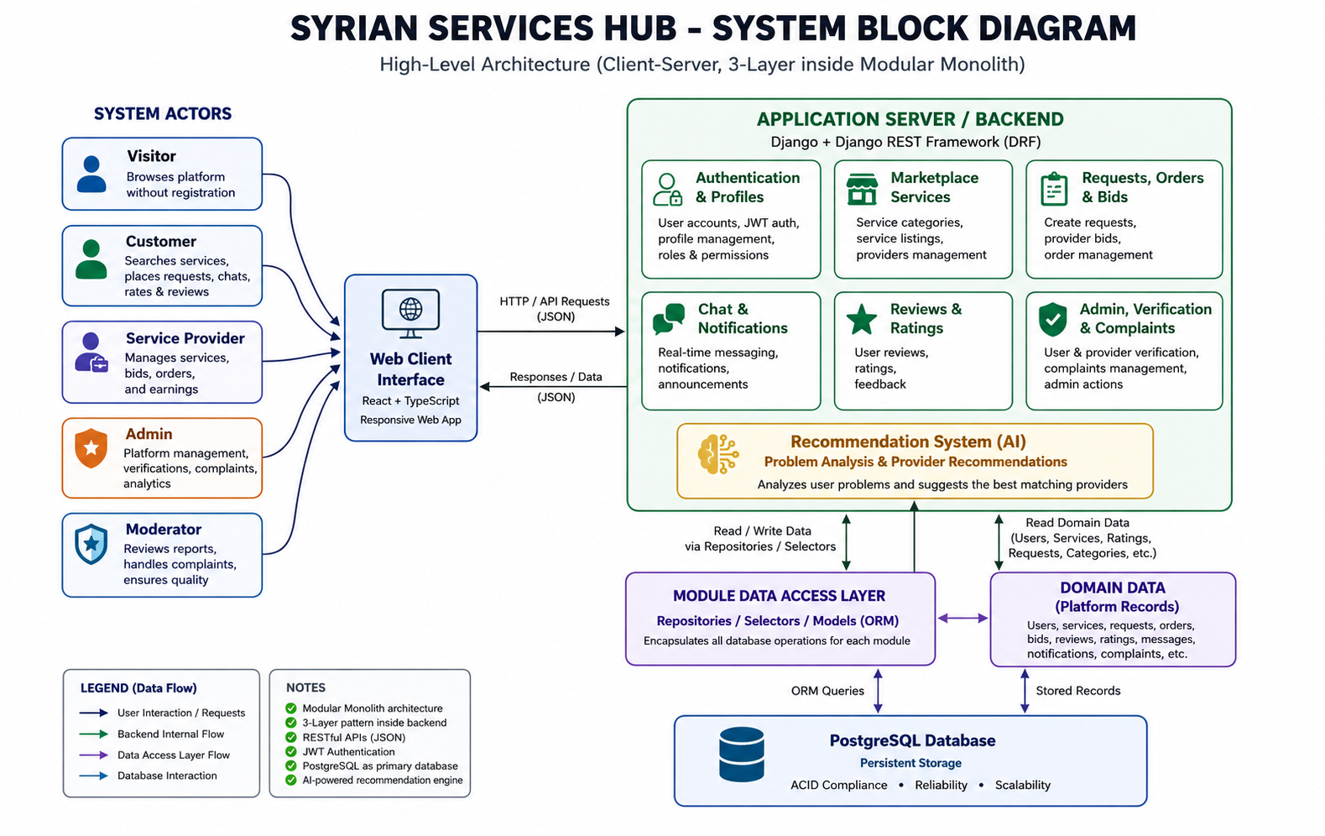
Figure 17 System Block Diagram of Syrian Services Hub

5.1.2 Architectural Pattern Used
Syrian Services Hub follows a client-server architecture implemented through a three-tier design pattern. This architectural pattern was selected because it provides clear separation between the presentation layer, the application or business logic layer, and the data layer. Such separation is well suited to a web-based platform that must support multiple user roles, structured service workflows, and recommendation-oriented processing while remaining maintainable and scalable.
table 20 Architecture Layer Summary
Layer | Main Responsibility | Technology Direction
Presentation Layer | Provides the user interface for visitors, users, providers, and administrators; supports browsing, requests, offers, dashboards, and recommendation interaction. | React-based web interface
Business Logic Layer | Handles workflows, validation, role-based operations, recommendation processing, notifications, complaints, and verification management. | Django application logic and REST endpoints
Data Layer | Stores persistent platform records such as users, services, requests, offers, messages, complaints, ratings, and verification data. | PostgreSQL relational database

5.1.3 System Architecture Design
Within the presentation layer, users interact with the platform through role-oriented pages that support browsing, request submission, offer management, profile updates, and dashboard views. The business logic layer acts as the core processing unit of the system. It receives requests from the client side, validates input, enforces workflow rules, manages authorization, and coordinates recommendation processing. The data layer stores all persistent entities in a relational structure that preserves integrity and supports traceable interactions between actors and platform records.
The recommendation feature is integrated into the business logic layer rather than isolated as a separate external system. When a user describes a problem, the backend analyzes the submitted description and retrieves both suggested solutions and a suitable service provider based on the platform data and recommendation rules. This approach keeps the intelligent functionality connected to the main service marketplace workflow rather than treating it as an unrelated feature.
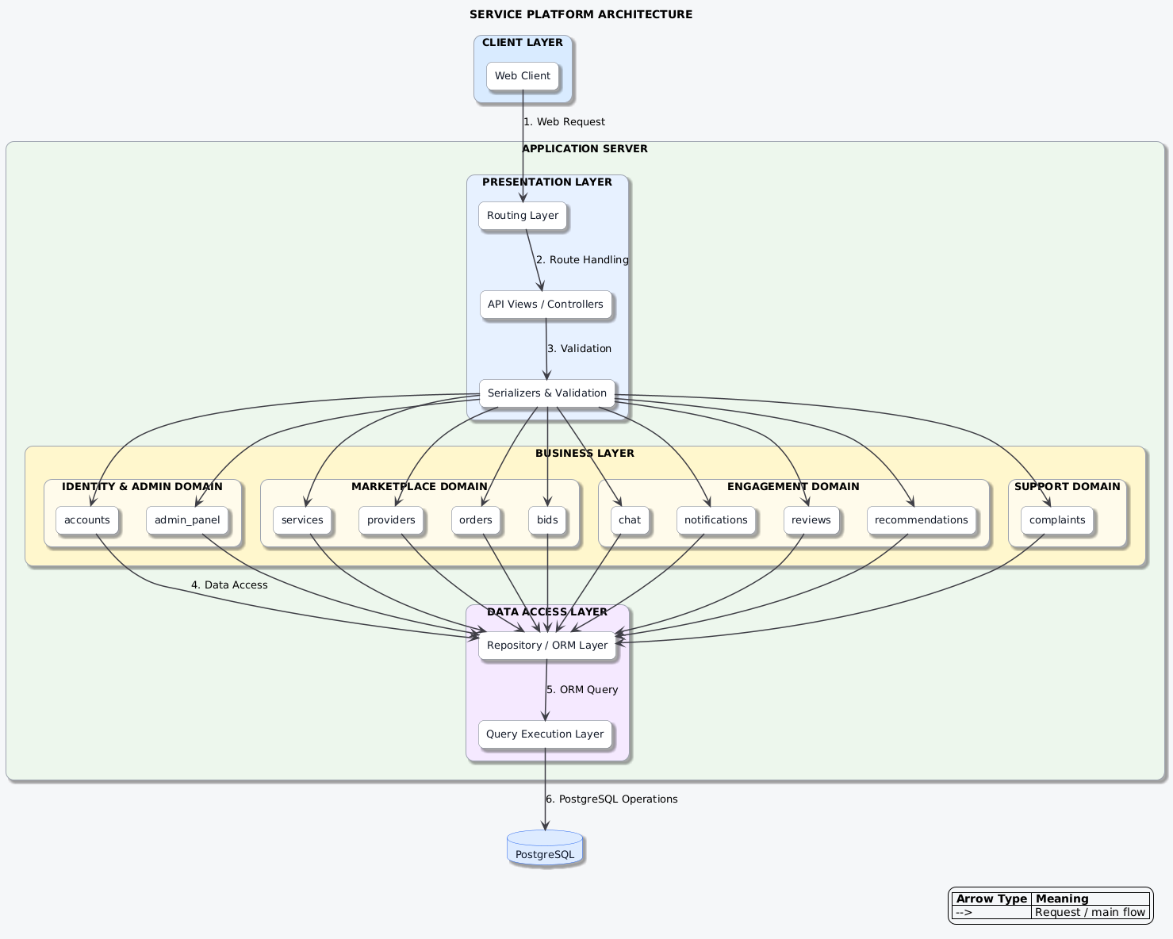
Figure 18 Architecture of Syrian Services Hub

5.1.4 Ask Assistant RAG Architecture
Ask Assistant is designed as a separate bounded capability rather than an extension of AI Recommendation. The knowledge module manages provider-owned sources, extracted documents, searchable chunks, embedding generation, ingestion jobs, visibility, and permission-aware retrieval. The customer_assistant module manages customer sessions, user questions, assistant answers, token and latency metadata, and citations that connect an answer to the supporting chunks.
The ingestion pipeline accepts an approved provider source, validates ownership and file rules, extracts and normalizes text, divides it into chunks, generates embeddings, and activates the source only after successful indexing. At question time, retrieval filters candidates by provider, source status, visibility, and access scope before applying vector similarity search. The selected evidence is then supplied to the answer-generation step, and the response is stored with citations.
The design follows a grounding-first safety model. Retrieved document text is treated as evidence rather than executable instruction, private and archived sources are excluded, unsupported answers are rejected, and the user sees a clear insufficient-evidence message when the knowledge base cannot support a reliable answer.

5.2 Database Design
The database design of Syrian Services Hub is based on a relational model that supports the core entities of the service marketplace and the relationships between them. The database must preserve data consistency for user accounts, provider profiles, services, requests, offers, messages, complaints, ratings, verification records, and administrative actions. A structured relational design is especially important because the platform includes many interconnected workflows and role-based operations.

5.2.1 Entity Relationship Model
The entity relationship model identifies the main data entities of the system and defines how they are connected. At a minimum, the model should include users, provider profiles, services, service requests, offers, conversations, messages, ratings, complaints, and verification requests. These entities reflect the operational structure of the platform and support both the direct service workflow and the open request-and-offer workflow.
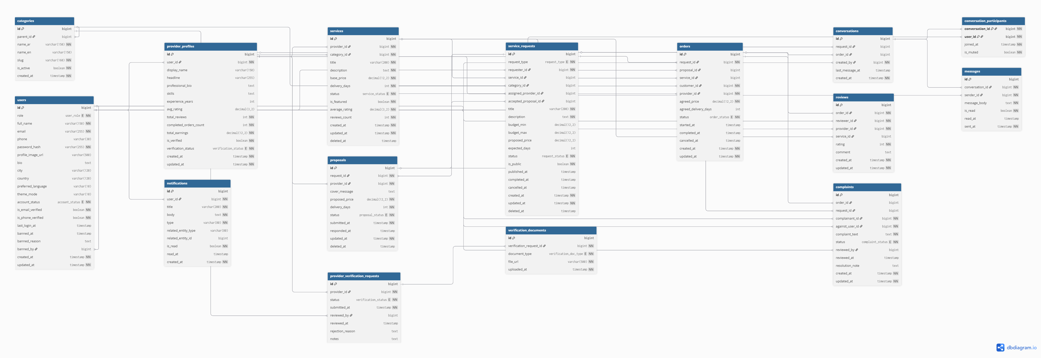
Figure 19 ER Diagram of Syrian Services Hub

5.2.2 Relational Schema
The relational schema translates the conceptual entity model into database tables with identifiable keys and structured attributes. Table 5.2 summarizes the main tables required to support the platform logic.
table 21 Core Relational Schema of Syrian Services Hub
Table Name | Primary Key | Selected Attributes | Purpose
User | user_id | full_name,email, password_hash, role, phone, is_active | Stores platform accounts for visitors after registration, users, providers, and administrators.
ProviderProfile | provider_profile_id | user_id, bio, location, skills, verification_status | Stores professional information related to a service provider.
Category | category_id | name, description | Organizes services into searchable categories.
Service | service_id | provider_profile_id, category_id, title, description, price, delivery_time, status | Stores ready-made services published by providers.
ServiceRequest | request_id | user_id, category_id, title, problem_description, budget, status, created_at | Stores open service-demand advertisements posted by users.
Offer | offer_id | request_id, provider_profile_id, offer_price, delivery_time, proposal_text, status | Stores provider offers submitted in response to service requests.
Conversation | conversation_id | user_id, provider_profile_id, request_id, created_at | Represents a communication channel between the involved parties.
Message | message_id | conversation_id, sender_user_id, body, sent_at, read_status | Stores messages exchanged within a conversation.
Rating | rating_id | service_id, rater_user_id, provider_profile_id, score, feedback, created_at | Stores ratings and feedback after service completion.
Complaint | complaint_id | submitted_by, target_user_id, reason, details, status, created_at | Stores platform complaints and moderation records.
VerificationRequest | verification_id | provider_profile_id, submitted_at, status, reviewed_by, reviewed_at | Stores provider verification submissions and review outcomes.
KnowledgeSource | knowledge_source_id | provider_id, source_type, title, visibility, status, checksum | Stores provider-owned customer-facing sources and their ingestion state.
KnowledgeChunk | knowledge_chunk_id | source_id, chunk_index, content, embedding, token_count, metadata | Stores searchable evidence segments and vector embeddings used by Ask Assistant.
AssistantSession | assistant_session_id | customer_id, provider_id, created_at, updated_at | Groups the customer conversation within a provider-specific context.
AssistantTurn | assistant_turn_id | session_id, role, content, latency_ms, token_usage, created_at | Stores customer questions and assistant answers in chronological order.
AssistantCitation | assistant_citation_id | turn_id, chunk_id, source_id, excerpt, rank | Links a generated answer to the exact supporting evidence displayed to the user.
In addition to the core tables above, the final implementation may also include supporting tables such as Notification, Attachment, or AuditLog depending on the chosen level of administrative control and traceability.

5.2.3 Constraints and Data Integrity Rules
To preserve consistency and prevent invalid platform states, the relational schema uses primary keys, foreign keys, uniqueness rules, and selected validation constraints. Table 5.3 summarizes representative constraints applied to major entities.
table 22 Main Database Constraints
Table | Constraint Type | Rule | Purpose
User | UNIQUE | email must be unique | Prevents duplicate accounts with the same email.
User | CHECK | role IN (visitor, user, provider, admin) | Restricts the role to valid system roles.
ProviderProfile | FOREIGN KEY | user_id references User(user_id) | Ensures every provider profile belongs to a valid user account.
Service | FOREIGN KEY | provider_profile_id references ProviderProfile(provider_profile_id) | Prevents orphan service records.
Service | CHECK | price >= 0 and delivery_time > 0 | Prevents invalid service values.
ServiceRequest | FOREIGN KEY | user_id references User(user_id) | Links each request to its owner.
Offer | FOREIGN KEY | request_id references ServiceRequest(request_id) | Ensures every offer belongs to a valid request.
Message | FOREIGN KEY | conversation_id references Conversation(conversation_id) | Preserves message-conversation integrity.
VerificationRequest | CHECK | status IN (pending, approved, rejected, revoked) | Supports both granting and revoking verification status.
KnowledgeSource | OWNERSHIP / STATUS | provider_id must match the selected provider; only active customer-visible sources may be retrieved | Prevents cross-provider and inactive-source leakage.
KnowledgeChunk | VECTOR / FK | embedding is stored with a valid source reference and chunk order | Supports similarity retrieval while preserving traceability to the source.
AssistantSession | OWNERSHIP | customer_id and provider_id define the authorized conversation scope | Prevents a session from searching unrelated providers.
AssistantCitation | FK / INTEGRITY | each citation must reference the assistant turn and a retrieved chunk from an authorized source | Ensures every displayed citation can be traced to evidence.

5.3 External API Design
Syrian Services Hub is designed as a web platform in which the frontend interacts with the backend through REST-oriented endpoints. These endpoints allow the client side to retrieve services, submit requests, manage offers, exchange messages, and perform trust-related operations in a structured and predictable way. The API layer also allows the recommendation feature to be requested from the user interface in a standardized form.
Table 5.4 presents representative endpoints used to support the main platform workflows. The final implementation may contain additional endpoints depending on modular refinement and administrative needs.
table 23 Representative API Endpoints
Method | Endpoint | Main Function | Role | Response Type
POST | /api/auth/register | Register account | User / Provider | JSON
POST | /api/auth/login | User login | All registered roles | JSON
GET | /api/services | Browse services | Visitor / User | JSON list
POST | /api/services | Create service | Provider | JSON
POST | /api/requests | Create service request | User | JSON
POST | /api/offers | Submit offer | Provider | JSON
GET | /api/conversations/{id}/messages | Get messages | Authorized parties | JSON list
POST | /api/recommendations | Get suggested solutions and provider | User | JSON
POST | /api/verification-requests | Submit verification request | Provider | JSON
PATCH | /api/admin/providers/{id}/revoke-verification | Revoke verification | Admin | JSON
POST | /api/v1/customer-assistant/questions/ | Ask a provider-specific question and receive a grounded cited answer | Authenticated User | JSON
GET | /api/v1/customer-assistant/sessions/{id}/turns/ | Retrieve authorized Ask Assistant conversation history | Authenticated User | JSON
POST | /api/v1/knowledge/sources/ | Upload a provider-owned customer-facing knowledge source | Provider | JSON
POST | /api/v1/knowledge/sources/{id}/reindex/ | Reprocess and re-embed an owned knowledge source | Provider / Admin | JSON

5.4 Security and Access Design
Security and access control are essential in Syrian Services Hub because the platform manages user identities, provider records, direct interaction, complaints, and verification-related actions. The security design therefore focuses on access control, protected authentication, moderated trust features, and the limitation of sensitive actions to authorized roles only.
Ask Assistant adds security requirements beyond ordinary role-based access. Retrieval is permission-first: provider ownership, source visibility, active status, and customer scope are applied before semantic similarity. Retrieved documents are treated as untrusted data, not system instructions, and citations are validated against the evidence used. Rate limiting, file-type and size validation, audit metadata, and explicit insufficient-evidence handling reduce prompt-injection, leakage, and unsupported-answer risks.

5.4.1 Authentication and Authorization
The platform uses authenticated access for registered operations such as service publishing, request posting, offer submission, messaging, complaint handling, and verification management. Authorization is role-based, meaning that access rights depend on whether the account belongs to a user, provider, or administrator. This ensures, for example, that only providers can publish services, only users can post service-demand advertisements, and only administrators can approve or revoke verification status.

5.4.2 Verification and Revocation Control
Verification is treated as a controlled administrative process rather than an uncontrolled profile label. Providers can submit verification requests, while administrators review the submitted evidence and either approve or reject the request. In addition, the design allows administrators to revoke verification later if platform policies are violated or if the verification status becomes invalid. This revocation capability is important because it preserves platform trust and keeps verification under active administrative control rather than a one-time irreversible decision.

5.4.3 Data Protection and Operational Integrity
The design protects operational integrity by restricting direct access to sensitive records and by preserving consistency between accounts, provider profiles, services, requests, offers, and complaints. Input validation, controlled workflow transitions, and role-limited administrative actions reduce the risk of invalid data states and unauthorized system behavior. Recommendation processing is also treated as a backend-governed operation so that the returned suggestions remain tied to platform data rather than uncontrolled client-side logic.

Section Four: Implementation and Testing

Chapter Six: Implementation Environment and Tools
This chapter documents the practical environment used to build Syrian Services Hub and explains the main tools, frameworks, libraries, and execution settings that supported the implementation process. It describes the software stack used for frontend and backend development, the database platform, the testing utilities, dependency management, and the source-control practices applied during development. The chapter also clarifies the relationship between the selected technologies and the system architecture, especially in supporting the client-server and three-tier design adopted by the project.

6.1 Software Tools and Libraries Used
The implementation of Syrian Services Hub relied on a modern web-development stack supported by practical development and testing tools. The selected tools were chosen to match the requirements of a role-based service marketplace platform with structured workflows, database persistence, API communication, and recommendation-oriented processing. The toolset combines frontend development, backend implementation, database management, source control, and API inspection in a way that supports maintainability and modular growth.
table 24 Main software tools and libraries used in the implementation environment
Tool / Library | Role in the Project | Usage Context
Visual Studio Code | Primary development environment | Used for editing source files, project navigation, debugging, and managing the implementation workflow.
React | Frontend user interface library | Used to build the client-side pages, reusable components, dashboards, and interaction flows.
TypeScript | Frontend logic and interactivity | Used to implement component behavior, form interaction, API calls, and client-side state handling.
Django | Backend web framework | Used to implement business logic, role-based workflows, request handling, recommendation processing, and server-side validation.
PostgreSQL | Database management system | Used to store users, provider profiles, services, requests, offers, messages, verification records, and other persistent data.
Postman | API testing and inspection tool | Used to test endpoints, verify request-response behavior, and inspect backend API functionality.
Git / GitHub | Source control and revision tracking | Used to manage versions of the codebase and maintain development history.
OpenAI Python SDK | Embedding and answer-generation integration | Used by the RAG services to create vector embeddings and generate grounded answers from retrieved evidence.
pgvector | Vector storage and similarity search | Extends PostgreSQL so knowledge chunks can be retrieved by embedding similarity after authorization filters are applied.
pypdf, python-docx, openpyxl, tiktoken | Document extraction and token-aware chunking | Supports ingestion of approved provider files and preparation of searchable knowledge chunks.

6.2 Development Environment and Project Structure
The development environment of Syrian Services Hub was organized to support the separation between the frontend client, the backend application logic, and the data layer. This organization reflects the adopted three-tier architecture and helps maintain clarity between presentation-related files, server-side modules, and persistent data resources. The project structure also supports the modular handling of services, requests, offers, communication, trust-related processes, and recommendation logic.
At the implementation level, the environment was centered on a local development workflow in which the frontend and backend were developed as cooperating application layers, while the database operated as the persistent storage layer. This arrangement made it possible to test individual features incrementally while preserving a clear architectural boundary between interface behavior, business rules, and stored records.
table 25 High-level implementation environment structure
Project Layer | Representative Elements | Purpose
Client Layer | React pages, components, forms, dashboards | Provides the user-facing interface for visitors, users, providers, and administrators.
Application Layer | Django views, serializers, business logic, recommendation processing | Handles validation, workflows, role-based actions, and system behavior.
Data Layer | PostgreSQL tables, relations, stored records | Maintains persistent data and supports retrieval, updates, and structured relationships.
RAG Support Layer | knowledge and customer_assistant modules, OpenAI adapters, retrieval selectors, ingestion workers, vector-enabled models | Separates provider knowledge ingestion and customer question answering from recommendation processing.

6.3 Programming Languages and Frameworks
The implementation of the platform combined frontend and backend technologies that are widely used in modern web systems. React and TypeScript were used on the client side to support dynamic interaction, reusable interface components, stronger type safety, and responsive user flows. On the server side, Django provided the backend framework responsible for routing, validation, workflow handling, recommendation-related processing, and data interaction. This combination was appropriate for a marketplace platform that requires clear separation between user interaction and backend business logic while still maintaining practical development efficiency.
table 26 Programming languages and frameworks used by the project
Technology | Type | Contribution to the System
TypeScript | Programming language | Implements client-side interactivity, request handling, and frontend behavior.
React | Frontend framework/library | Builds dynamic user interfaces and reusable visual components.
Python | Programming language | Supports backend implementation through the Django framework.
Django | Backend framework | Implements APIs, workflow logic, data validation, and recommendation-related processing.
SQL | Database query language | Supports data definition and data manipulation through the PostgreSQL backend.
OpenAI API | AI service integration | Provides embedding generation and evidence-constrained response generation for Ask Assistant.
pgvector | PostgreSQL extension | Stores vector embeddings and enables similarity search over authorized knowledge chunks.

6.4 Database Server and Operating System
Syrian Services Hub uses PostgreSQL as the main database server because it provides reliable relational storage, strong support for structured data modeling, and good compatibility with backend application frameworks. PostgreSQL is appropriate for a system that manages multiple related entities such as users, services, service requests, offers, messages, complaints, verification records, and recommendation-related data references.
At the operating-system level, the development workflow depended on a standard personal-computer development environment suitable for local web implementation, testing, and integration between the client, backend, and database layers. The exact operating-system details may vary between development machines, but the project environment was prepared to support typical local execution of the selected stack without requiring specialized deployment infrastructure at this stage.
table 27 Database and execution environment summary
Environment Element | Selected Option | Reason for Selection
Database Server | PostgreSQL | Provides reliable relational persistence, strong integrity support, and suitability for multi-entity platform data.
Execution Model | Local development environment | Supports iterative testing and controlled feature verification during implementation.
System Context | Web-based client-server environment | Matches the platform architecture and the requirement for role-based online interaction.
Vector Capability | PostgreSQL with pgvector | Keeps relational ownership and visibility metadata together with vector search for the RAG knowledge base.

6.5 Dependencies
The project depends on a set of framework and runtime packages required to support frontend rendering, backend execution, database connectivity, and API communication. In the backend environment, dependencies are managed through Python package installation, while the frontend relies on a TypeScript-based toolchain and package management for component rendering and interface behavior. Dependency tracking is important because it ensures that the platform can be rebuilt consistently and that the implementation environment remains reproducible.
table 28 Main dependency groups used by the project
Dependency Group | Examples | Function
Backend packages | Django and related Python packages | Provide routing, validation, ORM support, and server-side functionality.
Frontend packages | React and TypeScript dependencies | Provide rendering, state management, and component-based interface behavior.
Database connector packages | PostgreSQL integration packages | Enable communication between backend logic and persistent storage.
Testing / utility packages | Request inspection and development utilities | Support API validation, debugging, and controlled implementation checks.
RAG and document-processing packages | openai, pgvector, pypdf, python-docx, openpyxl, tiktoken | Provide embeddings, grounded answer generation, vector persistence, file extraction, and token-aware chunking.

6.6 Version Control and Source Management Tools
Version control was handled through Git and GitHub in order to preserve the development history of Syrian Services Hub and reduce the risk of losing implementation progress during iterative work. Source control is especially important in a project that evolves across analysis, design, and implementation because code revisions must remain traceable and recoverable. Git-based source management also supports structured modification of frontend and backend modules, incremental refinement of project files, and safer maintenance of the codebase over time.
table 29 Version control and source-management tools
Tool | Purpose | Practical Benefit
Git | Version control | Tracks changes, supports rollback, and preserves implementation history.
GitHub | Repository hosting and collaboration | Stores the codebase remotely and supports organized source management.

6.7 Continuous Integration and Deployment Tools
At the current project stage, Syrian Services Hub did not rely on a dedicated automated continuous-integration or deployment pipeline. The implementation process focused on controlled local development, iterative testing, and direct verification of frontend-backend interaction. This is acceptable within the scope of an academic graduation project because the primary objective at this stage is to build, validate, and document the core system rather than establish a production-grade deployment workflow. Nevertheless, the project structure remains suitable for future extension toward CI/CD integration if the system is later developed into a larger deployable platform.
table 30 CI/CD status within the current project scope
Aspect | Current Status | Future Possibility
Continuous Integration | Not automated in the current academic scope | Can be extended later through automated testing and build pipelines.
Continuous Deployment | Not applied at the current project stage | Can be introduced when the system moves toward hosted production deployment.

6.8 Testing Environment
The testing environment of Syrian Services Hub was based primarily on local execution and controlled validation of system behavior during development. Testing covered the interaction between the React frontend, the Django backend, and the PostgreSQL database, while Postman was used to verify API behavior independently from the user interface when needed. This environment allowed the project to validate request handling, role-based actions, service workflows, recommendation responses, and data persistence before moving to broader evaluation activities described in the testing chapter.
Local testing was appropriate for the current implementation stage because it enabled quick iteration, isolated debugging, and repeated validation of major workflows such as service publishing, request posting, offer management, messaging, verification handling, and recommendation generation. As a result, the testing environment supported both technical correctness and development efficiency during the implementation process.
table 31 Testing environment elements used during implementation
Testing Element | Environment / Tool | Purpose
Frontend validation | Local browser execution | Checks interface behavior, navigation, forms, and dashboard interaction.
Backend validation | Local Django execution | Checks logic processing, endpoint behavior, and workflow correctness.
API testing | Postman | Validates request-response structures and endpoint correctness.
Database validation | PostgreSQL local execution | Checks data persistence, relations, and stored results after operations.
RAG validation | Django test client, PostgreSQL/pgvector, mocked or controlled OpenAI responses | Checks ingestion, permission filtering, retrieval relevance, citations, insufficient-evidence behavior, and API contracts.

Overall, the implementation environment of Syrian Services Hub reflects a practical and coherent web-development setup that is consistent with the system architecture, the project requirements, and the academic scope of the graduation project.

Chapter Seven: Software Implementation
This chapter presents the practical implementation of Syrian Services Hub and explains how the designed architecture was translated into an operational software structure. It covers the project folder organization, the implementation of the main functional modules, the API layer, the data-access responsibilities, the business-logic layer, the user interface, and the implementation status of the intelligent recommendation-oriented functionality.

7.1 Project Structure and File Organization
The implementation of Syrian Services Hub follows a repository structure that separates the frontend, backend, documentation, and tracking assets of the project. According to the repository definition, the platform is built as a full-stack service marketplace with a React and TypeScript frontend and a Django plus Django REST Framework backend. The codebase is organized to support incremental development, clear domain separation, and maintainable delivery artifacts.
table 32 High-level repository structure of Syrian Services Hub
Directory | Purpose
frontend/ | Contains the client-side application, user interface pages, routing, state management, and API integration logic.
backend/ | Contains the Django and DRF server-side code, domain modules, authentication, business rules, and API endpoints.
docs/ | Contains architecture, system, API, security, and delivery documentation.
tracking/ | Contains work-management records, decisions, risks, changelog notes, and open implementation questions.
.vscode/ and root files | Contain local editor configuration and repository-level setup files.
backend/apps/knowledge/ | Contains provider knowledge-source models, ingestion services, extraction, chunking, embeddings, selectors, and retrieval logic.
backend/apps/customer_assistant/ | Contains Ask Assistant sessions, turns, citations, question service, API serializers, views, and routes.

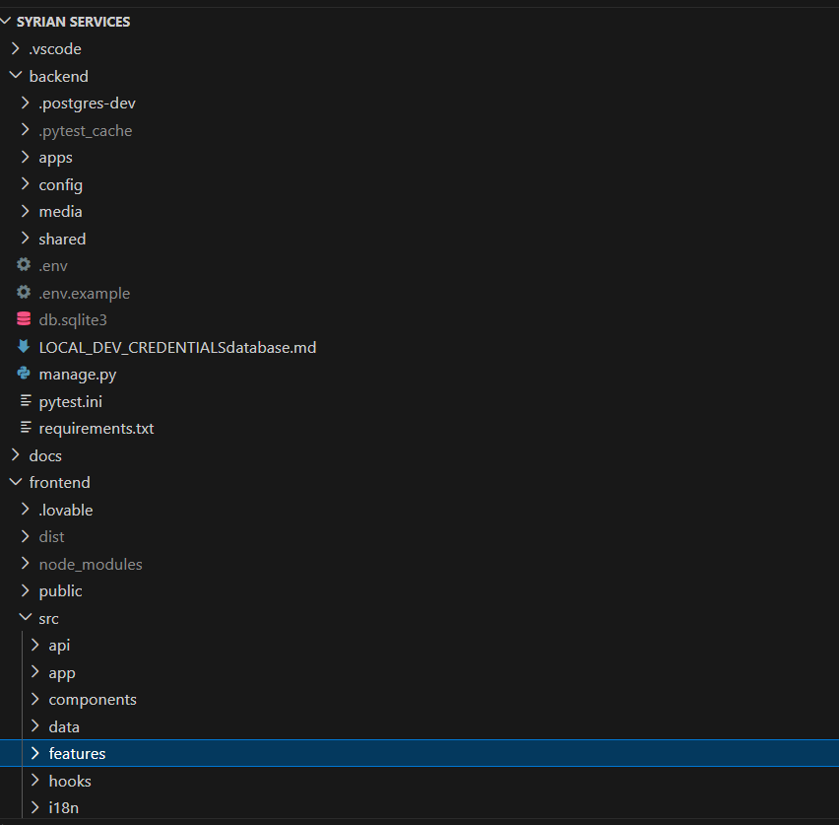
Figure 20 Placeholder for the project structure

7.2 Implementation of Major Functional Modules
The backend implementation is organized around a set of domain-oriented modules that collectively realize the service marketplace workflows of the platform. The repository identifies the core domains as accounts, providers, services, orders, bids, chat, complaints, reviews, notifications, and admin_panel. In practical terms, these modules implement the functional scope discussed in the requirements chapter, including user accounts, provider profiles, service publishing, service-demand workflows, offer submission, communication, trust-related actions, and administrative supervision. This modular organization improves maintainability by separating concerns while keeping all business capabilities within a unified backend project.
table 33 Main implementation modules and their responsibilities
Module | Main Responsibility
accounts | User registration, login, session handling, profile basics, and role-aware account operations.
providers | Provider-specific profiles, provider status, and provider-related marketplace data.
services | Service creation, update, listing, and marketplace presentation logic.
orders | Customer-side service requests and order progression workflows.
bids | Offer and bid submission, review, and response handling between providers and users.
chat | Message exchange and conversation support between marketplace participants.
complaints and reviews | Trust-building functions such as complaints, dispute-related actions, and user feedback records.
notifications and admin_panel | System notifications, administrative monitoring, moderation-related supervision, and control operations.
knowledge | Provider-owned knowledge sources, documents, chunks, ingestion jobs, embeddings, visibility, and retrieval.
customer_assistant | Authenticated provider-specific questions, conversation sessions, grounded answers, insufficient-evidence handling, and citations.

7.3 API Implementation
Add Service Listing API
This section presents a simple implemented API from the Syrian Services Hub project. The selected API allows an authenticated service provider to create a new service listing on the platform.
API Name | Create Service Listing API
HTTP Method | POST
Endpoint | /api/v1/services/me/
Access | Authenticated provider only
Purpose | Create and store a new service listing for the logged-in provider

Request Processing Flow
1 | The provider submits the service information through a POST request.
2 | The API validates the submitted fields.
3 | The service layer confirms that the logged-in user is a provider.
4 | The new service record is saved and returned in the response.

1. Main API Route
File Location: backend/config/urls.py
PYTHON | ROUTING
path("api/v1/services/", include("apps.services.api.urls")),

Explanation: This line registers the services module in the main backend routing file. Therefore, every service-related endpoint begins with the /api/v1/services/ path prefix.

2. Service Creation Endpoint
File Location: backend/apps/services/api/urls.py
PYTHON | ENDPOINT
path("me/", MyServicesView.as_view(), name="services-me"),

Explanation: This route connects the /me/ path to MyServicesView. Combined with the main prefix, the final service creation endpoint is POST /api/v1/services/me/.3. Request Data Validation
File Location: backend/apps/services/api/serializers.py
PYTHON | SELECTED VALIDATION FIELDS
class ServiceCreateUpdateSerializer(serializers.Serializer):
title = serializers.CharField(max_length=255)
description = serializers.CharField()
category = serializers.CharField(max_length=60)
price = serializers.DecimalField(max_digits=10, decimal_places=2)
price_type = serializers.ChoiceField(
choices=["fixed", "hourly", "starting_at"]
)

Explanation: The serializer checks the essential service information before creation. It validates the title, description, category, price, and allowed price type values. Optional fields such as duration and active status are omitted here for brevity.

4. API View Implementation
File Location: backend/apps/services/api/views.py
PYTHON | CREATE REQUEST HANDLER
class MyServicesView(APIView):
permission_classes = [permissions.IsAuthenticated]
def post(self, request):
serializer = ServiceCreateUpdateSerializer(data=request.data)
serializer.is_valid(raise_exception=True)
service = ServiceListingService.create_service(
actor=request.user,
attrs=serializer.validated_data
)
return success_response(
data={"service": ServiceSerializer(service).data},
message="Service created",
status_code=201
)

Explanation: The view accepts a POST request from an authenticated user, validates the request data, calls the service creation logic, and returns the newly created service with HTTP status code 201.

5. Business Rule and Database Creation
File Location: backend/apps/services/services/service_service.py
PYTHON | BUSINESS LOGIC
def create_service(*, actor, attrs):
if actor.role != "provider":
raise PermissionDeniedDomain("Only providers can create services.")
provider = ProviderService.get_or_create_for_user(actor)
normalized_attrs = dict(attrs)
normalized_attrs["category"] = provider.category
return ServiceRepository.create(provider=provider, **normalized_attrs)

Explanation: The business layer verifies that only providers can add services, creates the record through the repository layer, and uses the category stored in the provider profile before saving.

6. Example Request Body
JSON | REQUEST BODY
{
"title": "Home Electrical Repair",
"category": "Electrical",
"price": "50000.00",
"price_type": "fixed"
}

Explanation: The provider submits the main service details in JSON format.

7. Example Response Body
JSON | SUCCESS RESPONSE
{
"success": true,
"message": "Service created",
"data": {
"service": {
"id": 1,
"title": "Home Electrical Repair"
}
}
}

Explanation: The backend confirms successful creation and returns the created service data.

7.4 Implementation of the Data-Access Layer
The backend follows a layered organization in which persistence concerns are kept separate from request handling and higher-level business rules. The repository guidance states that persistence logic should remain in repositories and selectors, while API transport logic should remain in the presentation layer and business rules should remain in the service layer. This implementation choice supports cleaner domain boundaries and reduces the risk of mixing data-access code with workflow-specific logic. In practice, the data-access layer is responsible for retrieving, storing, and updating marketplace records such as users, services, orders, bids, chats, complaints, and reviews.
table 35 Data-access responsibilities in the implementation
Layer Element | Implementation Responsibility
Models and persistence structures | Represent stored entities and their relationships inside the PostgreSQL-backed backend system.
Repositories / selectors | Retrieve, filter, aggregate, and persist records required by the marketplace workflows.
Data transactions | Support reliable creation and update operations for service, order, bid, and interaction records.
RAG selectors and vector retrieval | Apply provider, visibility, status, and ownership filters before vector similarity search; return ranked chunks with source metadata for citation.

7.5 Implementation of the Business-Logic Layer
The business-logic layer is a central part of the implementation because it coordinates platform rules independently from both the user interface and the persistence mechanisms. The repository standards explicitly state that business rules should be kept in the backend service layer. This means that core workflow decisions, permission checks, ownership validation, marketplace state transitions, and trust-related rules are handled through server-side services rather than scattered across controllers or UI code. Such a design is especially important for Syrian Services Hub because the platform supports multiple roles, service requests, bids, reviews, complaints, and administrative actions that must remain consistent across the system.
table 36 Representative business-logic responsibilities
Business Area | Examples of Implemented Logic
Authentication and access control | Role-based authorization, ownership checks, and protected access to domain operations.
Marketplace workflow control | Validation of service, order, and bid actions according to platform rules and user roles.
Trust and supervision | Complaint-related handling, review constraints, and administrative control over monitored processes.
Verification governance | Verification status review and administrative control over provider verification states, including revocation when required.
Ask Assistant orchestration | Validate the selected provider and user scope, rewrite or normalize the question when needed, retrieve evidence, generate a grounded response, reject unsupported answers, persist turns, and create citations.

7.6 User Interface Implementation
The frontend implementation is built with React and TypeScript and is organized as the client-facing layer of the platform. The repository describes the frontend as an existing React application that was incrementally stabilized and refactored, which means that the implementation process focused on preserving useful interface value while improving structure and backend integration. The user interface supports the main marketplace roles and workflows through pages and interactive components for service browsing, authentication, profile interaction, service requests, bids, and role-aware dashboards. In addition, the frontend was integrated with backend contracts through API adapters, helping the client application operate against the implemented server-side modules rather than mock-only flows.

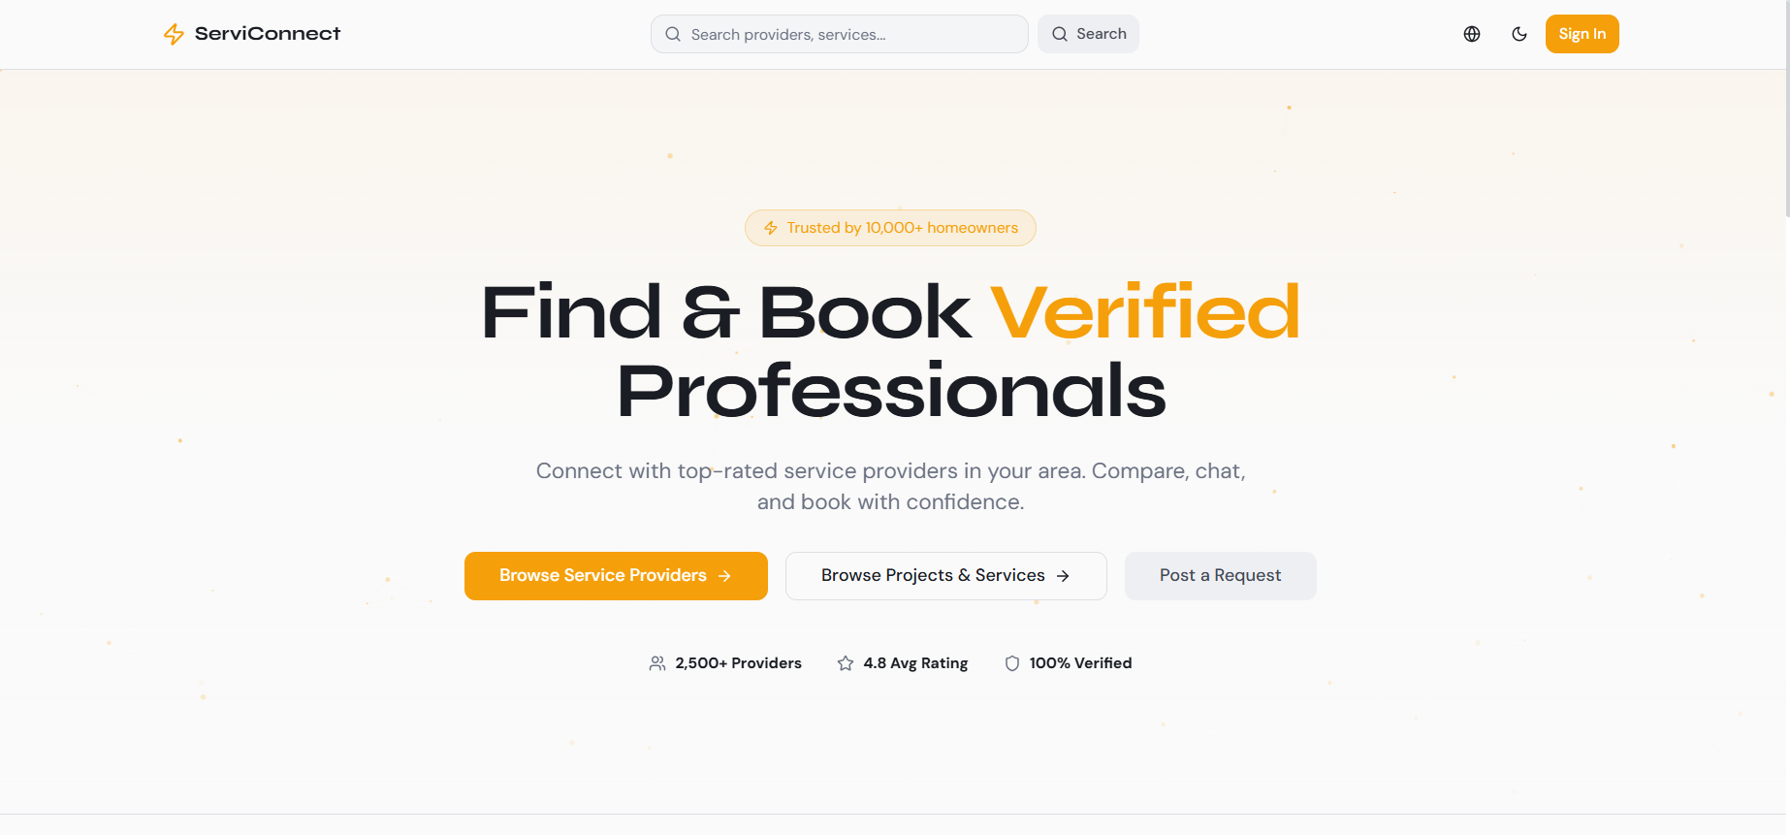
Figure 21 Placeholder for a main marketplace interface screenshot.

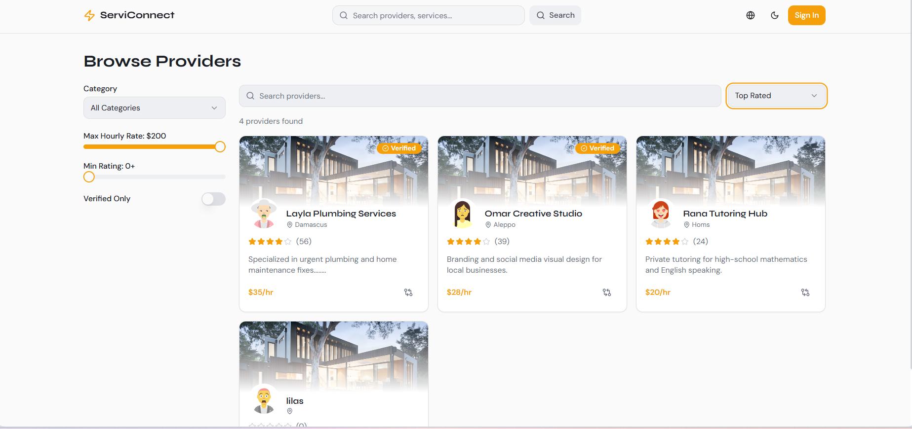
Figure 22 service-request interface screenshot

7.7 Implementation of the Intelligent Recommendation-Oriented Functionality
From the system-design perspective, Syrian Services Hub was defined as a smart service marketplace that includes recommendation-oriented support. However, the repository and implementation materials place the strongest current emphasis on the core marketplace foundation, domain modules, authentication migration, frontend-backend integration, and workflow integrity. For this reason, the intelligent aspect should be presented in the implementation chapter as a recommendation-oriented extension that is aligned with the platform architecture and the analyzed requirements, while the current implemented core clearly centers on the operational marketplace modules. This framing remains consistent with the project scope: the user submits a problem or need, and the platform is designed to support recommendation-oriented assistance that can suggest relevant service directions and suitable providers based on the described need. The architectural separation between frontend, business logic, and data access also makes this intelligent feature suitable for incremental extension without disrupting the core system modules.

table 37 Implementation positioning of the recommendation-oriented feature
Aspect | Implementation Interpretation
Input | A user-provided problem description or expressed service need.
Expected output | Suggested service direction and a suitable provider recommendation.
Architectural position | Implemented as an extensible logic component connected to marketplace data and workflow context.
Current implementation emphasis | Core marketplace modules and integration are primary; recommendation support is framed as the intelligent extension of the platform.

7.8 Implementation of Ask Assistant (RAG)
Ask Assistant is implemented separately from the recommendation-oriented feature. The repository contains dedicated backend domains named knowledge and customer_assistant. The knowledge domain owns provider sources, extracted content, chunks, embeddings, ingestion state, and retrieval. The customer_assistant domain owns sessions, question and answer turns, citations, and the service that coordinates the customer question workflow.
The main question endpoint is POST /api/v1/customer-assistant/questions/. It requires authentication, validates the provider-specific scope, invokes the assistant question service, and returns structured JSON containing the answer, citation data, and session information. Conversation turns can be retrieved through an authorized session-history endpoint, while knowledge-source endpoints allow providers to upload, archive, and reindex their own material.
During ingestion, supported files are validated and normalized, their text is extracted and divided into token-aware chunks, and embeddings are stored in PostgreSQL through pgvector. During retrieval, authorization and source-state filters are applied before vector similarity ranking. The retrieved chunks are passed as evidence to the OpenAI Responses API, and the generated answer is accepted only when it remains supported by that evidence.
The resulting answer is persisted with citations that reference the supporting source and chunk. If no sufficient evidence is available, Ask Assistant returns an explicit insufficient-evidence response. This behavior keeps factual provider question answering traceable and safe while preserving the independent purpose of AI Recommendation.

Overall, the implementation chapter shows that Syrian Services Hub was built on a practical full-stack foundation that matches the previously proposed architecture and supports the principal marketplace workflows of the project. The implemented structure also leaves room for the recommendation-oriented feature to evolve in a controlled manner while remaining consistent with the broader system design.

Chapter Eight: Testing and Evaluation
This chapter presents the testing and evaluation activities used to verify the behavior, reliability, and usability of Syrian Services Hub. The evaluation focuses on validating the main service marketplace workflows, role-based access behavior, communication features, administrative operations, and the intelligent recommendation functionality. The purpose of this chapter is to demonstrate that the system requirements can be translated into observable and testable behavior, and that the implemented platform can be assessed against clear acceptance criteria.

8.1 Test Plan
The test plan defines the scope, objectives, testing levels, testing environment, responsibilities, and acceptance criteria used to evaluate Syrian Services Hub. Since the project includes multiple interacting roles and workflows, the testing process emphasizes scenario-based validation of the main user journeys rather than isolated feature inspection only. The plan covers visitor browsing, user account operations, provider service management, service request creation, offer submission, messaging, review handling, complaint management, verification control, and problem-based recommendation support.
Ask Assistant testing is treated as a separate stream from recommendation testing. It verifies provider-specific authorization, source visibility, ingestion state, retrieval relevance, citation integrity, answer grounding, conversation ownership, and the expected insufficient-evidence response.
table 38 Test plan overview
Item | Description
Testing Objective | Verify that the main system workflows operate correctly and satisfy the documented functional and non-functional requirements.
Testing Scope | Accounts, services, service requests, offers, messaging, reviews, complaints, verification, dashboards, and recommendation functionality.
Testing Approach | Manual scenario-based testing supported by API validation for backend endpoints and workflow behavior.
Testing Environment | Local development environment using the implemented frontend, backend, database, and API testing tools.
Testing Tools | Browser-based testing, Postman for API checks, development logs, and database inspection when needed.
Acceptance Criteria | A workflow is accepted when it produces the expected result, prevents invalid behavior, respects permissions, and keeps stored data consistent.
RAG Testing Scope | Knowledge-source ingestion, provider ownership, active-source filtering, vector retrieval, Ask Assistant API, citations, session history, and insufficient-evidence handling.

8.2 Types of Testing
Several testing types are relevant to Syrian Services Hub because the platform combines user-facing interaction, backend services, database operations, and access-control rules. The testing strategy therefore includes functional testing for feature correctness, integration testing for communication between frontend and backend layers, system testing for full workflow validation, acceptance testing for user-oriented scenarios, security testing for permissions and protected operations, performance-oriented checks for responsiveness, and usability review for interface clarity.
table 39 Types of testing applied to Syrian Services Hub
Testing Type | Purpose | Examples in the Project
Functional Testing | Validate individual functions against expected behavior. | Login, service creation, request posting, offer submission, complaint creation.
Integration Testing | Verify interaction between frontend, API layer, backend logic, and database. | Submitting a request from the interface and storing it correctly in the database.
System Testing | Validate complete end-to-end workflows. | User posts a request; provider submits an offer; user accepts or rejects the offer.
Acceptance Testing | Check that key workflows satisfy stakeholder needs. | User can find a relevant service or provider using browsing or recommendation.
Security Testing | Verify role-based access and protected operations. | Only Admin can manage complaints or revoke provider verification.
Performance Checks | Observe responsiveness during common operations. | Browsing services, filtering, opening dashboards, and submitting forms.
Usability Review | Evaluate clarity, navigation, and user experience. | Checking whether forms, statuses, and actions are understandable.
RAG Grounding and Permission Testing | Verify that answers use only authorized active evidence and that every supported answer is traceable. | A provider-specific question returns a cited answer; private, archived, unrelated, or weak evidence is excluded and produces a safe response.

8.3 Test Diagrams
Test diagrams are used to summarize the testing workflow and show how major scenarios move from requirement selection to execution and result recording. They help clarify the relationship between requirements, test cases, expected results, and final evaluation. Since the actual detailed diagrams are maintained separately as project figures, this section reserves the required locations for inserting the final testing diagrams without increasing the working file size.

8.3.1 Test Case Diagram
The test case diagram should represent the main testable workflows of the platform, especially the scenarios that involve multiple actors or critical system behavior. These include service browsing, service request creation, offer submission, provider verification handling, complaint management, and recommendation generation.
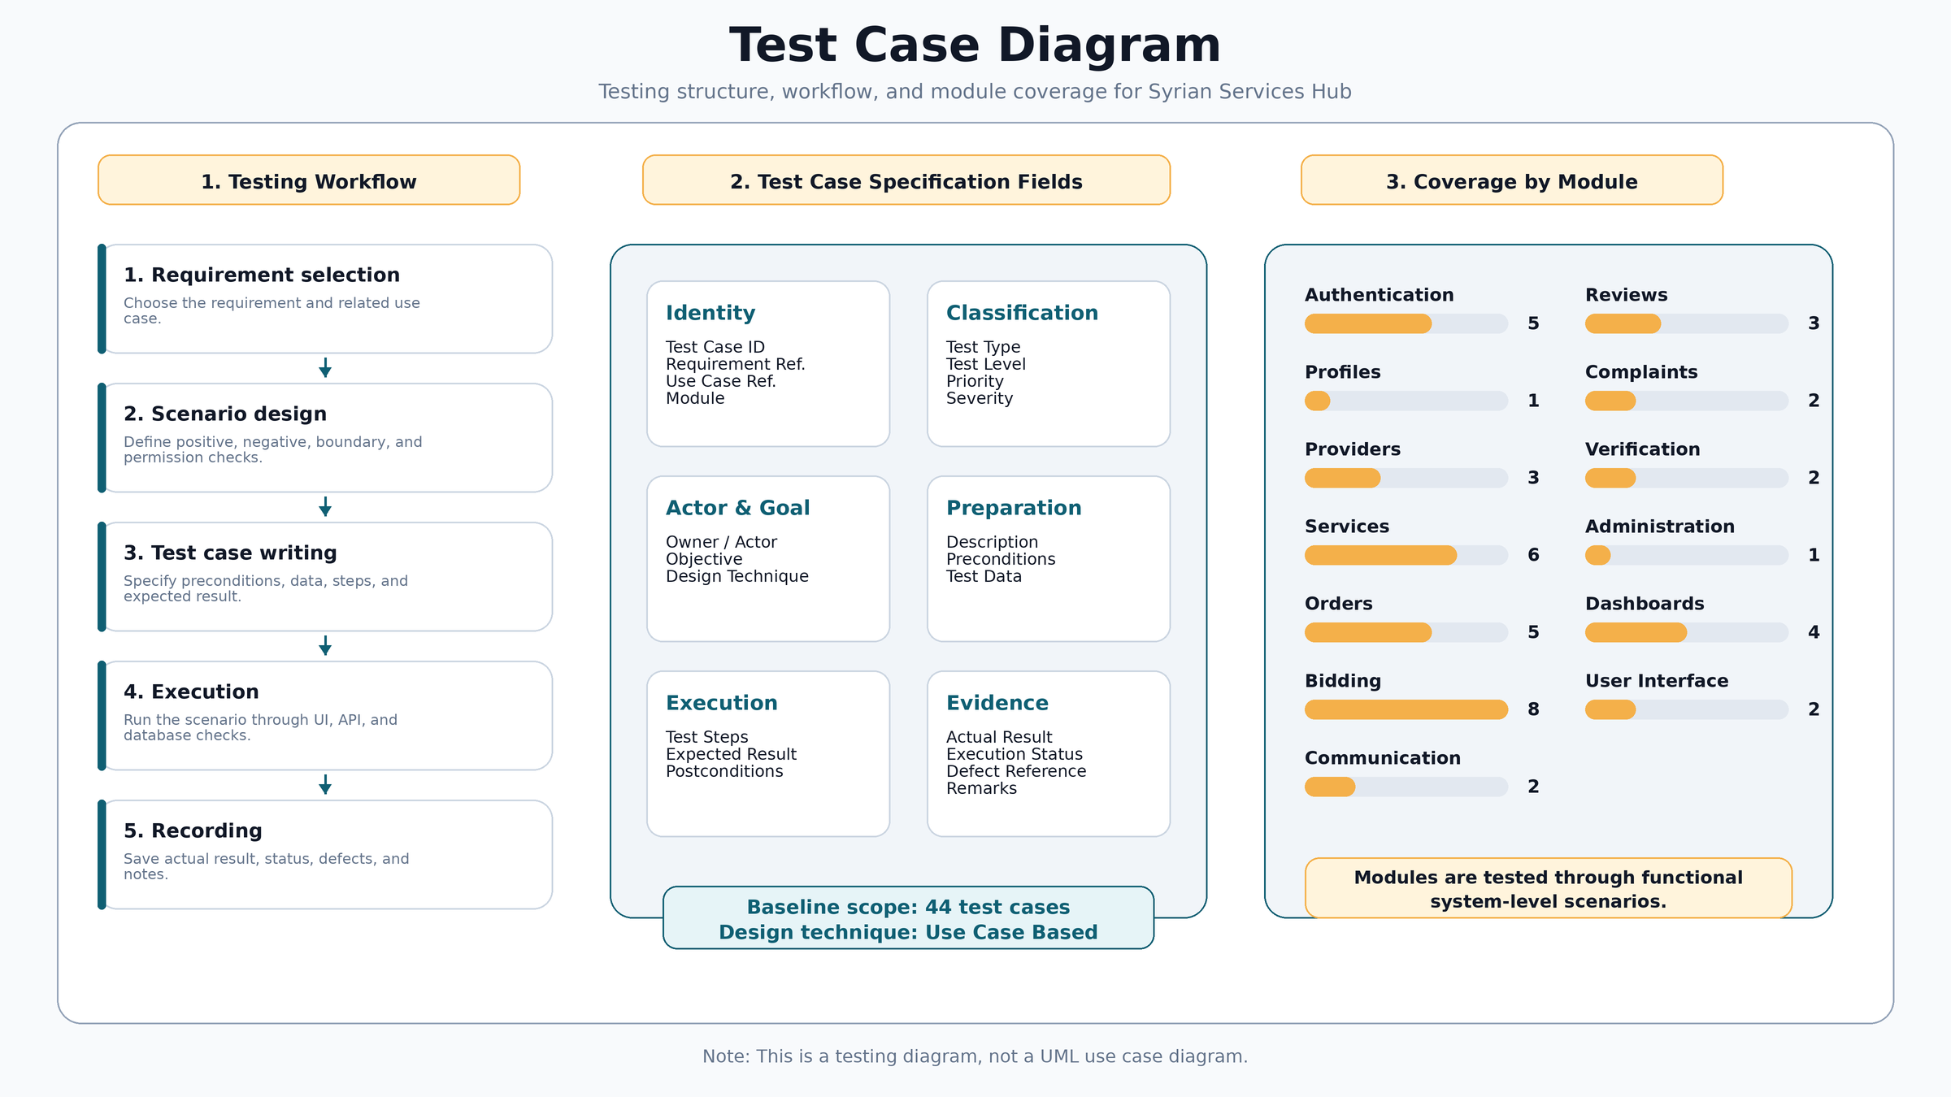

Figure 8.1: Test case diagram for the main testable workflows of Syrian Services Hub.

8.3.2 Test Results Diagram
The test results diagram should summarize the status of executed test cases, such as passed, failed, or pending items. It can be represented as a simple chart after the final execution results are confirmed. This keeps the evaluation section visually clear while preserving the detailed results in the testing tables.
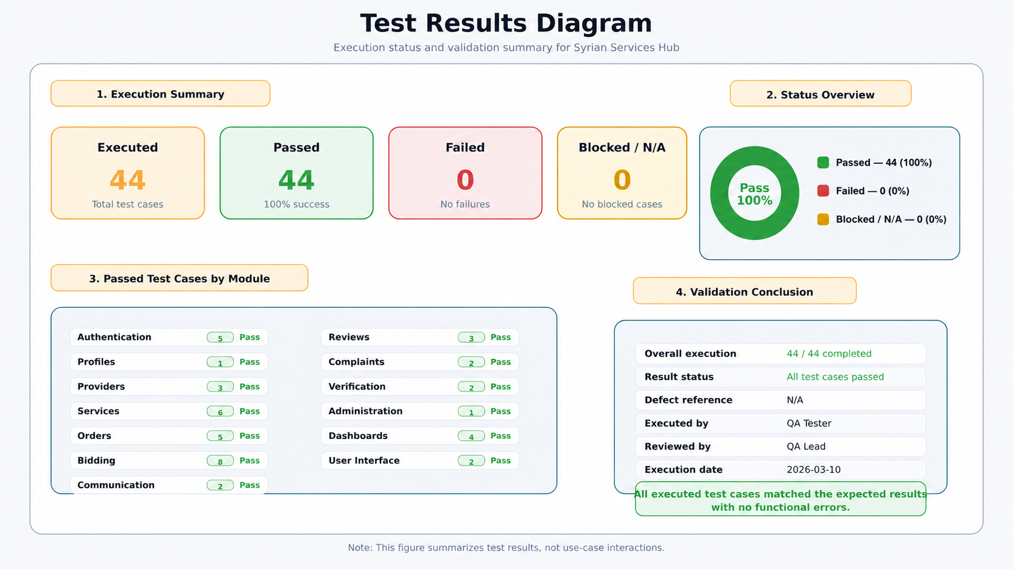

Figure 8.2: Summary diagram of testing results and validation status.

8.4 Test Results and Analysis
The following test cases summarize the main validation scenarios for Syrian Services Hub. The selected cases focus on the core platform behavior and the most important stakeholder workflows. They also include the intelligent recommendation feature and administrative verification control because these parts are essential to the system scope and should be verified clearly. The results are structured around expected outcomes and acceptance status, which makes the testing process traceable to the requirements and use case descriptions defined earlier.

table 40 Main test cases and validation results add services
Test Case ID | TC-SERV-001 | Requirement Ref. | SERV-001
Use Case Ref. | UC-10 | Module | Services
Title | Add Service | Owner / Actor | Provider
Test Type | Functional / Positive | Test Level | System
Priority | High | Severity | High
Risk Level | High | Automation Candidate | Medium
Objective | Verify that the system satisfies the Add Service requirement according to the defined main scenario. | Design Technique | Use Case Based
Description |  | Allows the service provider to add a new service that includes the service name, description, price, and execution duration.
Pre-conditions |  | - The required actor is logged in.  - The Add Service page is available.
Test Data / Input |  | - Service Name: Air Conditioner Maintenance  - Price: 150  - Execution Duration: Two days
Test Steps |  | - Open the screen or section related to the "Add Service" feature.  - Enter or select valid test data when needed.  - Perform the main action related to the feature.  - Review the result displayed to the user or actor.  - Verify that the change is saved or that data is retrieved from the database according to the expected behavior.
Expected Result |  | - A new service record linked to the service provider is created.  - No unexpected error messages or behavior that contradicts the scenario appear.  - The interface or data is updated according to the performed operation.
Post-conditions |  | A new service record linked to the service provider is created.
Exception Notes |  | There are no additional exception notes within this basic case; other scenarios are covered in later test cases.
Actual Result | The test case TC-SERV-001 for "Add Service" was executed successfully, and the actual result matched the expected result with no functional errors. | Execution Status | Pass
Defect Reference | N/A | Executed By | QA Tester
Reviewed By | QA Lead | Date Created | 2026-03-10
Execution Date | 2026-03-10 | Remarks / Notes | These fields were filled as an initial execution sample and can be updated during actual execution.

table 41 Main test cases and validation results submit offer

Test Case ID | TC-SERV-008 | Requirement Ref. | SERV-008
Use Case Ref. | UC-17 | Module | Orders
Title | Submit Offer on Service Request | Owner / Actor | Provider
Test Type | Functional / Positive | Test Level | System
Priority | High | Severity | High
Risk Level | High | Automation Candidate | Medium
Objective | Verify that the system satisfies the Submit Offer on Service Request requirement according to the defined main scenario. | Design Technique | Use Case Based
Description |  | Allows the service provider to respond to the service request sent by the user by submitting an offer that includes the price, duration, or execution details.
Pre-conditions |  | - The required actor is logged in.  - There is an incoming service request with Pending status.
Test Data / Input |  | - Proposed Price: 120  - Proposed Duration: 2 days  - Execution Details: Visit and inspection
Test Steps |  | - Open the screen or section related to the "Submit Offer on Service Request" feature.  - Enter or select valid test data when needed.  - Perform the main action related to the feature.  - Review the result displayed to the user or actor.  - Verify that the change is saved or that data is retrieved from the database according to the expected behavior.
Expected Result |  | - A new offer record linked to the service request is created, and the request status is updated to indicate that it has been answered with an offer.  - No unexpected error messages or behavior that contradicts the scenario appear.  - The interface or data is updated according to the performed operation.  - In the exceptional scenario: the offer data is invalid or the request is no longer in Pending status.
Post-conditions |  | A new offer record linked to the service request is created, and the request status is updated to indicate that it has been answered with an offer.
Exception Notes |  | The offer data is invalid or the request is no longer in Pending status.
Actual Result | The test case TC-SERV-008 for "Submit Offer on Service Request" was executed successfully, and the actual result matched the expected result with no functional errors. | Execution Status | Pass
Defect Reference | N/A | Executed By | QA Tester
Reviewed By | QA Lead | Date Created | 2026-03-10
Execution Date | 2026-03-10 | Remarks / Notes | These fields were filled as an initial execution sample and can be updated during actual execution.

table 42 Main test cases and validation results post new request

Test Case ID | TC-BID-001 | Requirement Ref. | BID-001
Use Case Ref. | UC-21 | Module | Bidding
Title | Post New Request | Owner / Actor | User
Test Type | Functional / Positive | Test Level | System
Priority | High | Severity | High
Risk Level | High | Automation Candidate | Medium
Objective | Verify that the system satisfies the Post New Request requirement according to the defined main scenario. | Design Technique | Use Case Based
Description |  | Allows the user to post a service request with the service description and expected budget.
Pre-conditions |  | - The required actor is logged in.  - The Post New Request page is available.
Test Data / Input |  | - Description: Electrical network installation  - Expected Budget: 500
Test Steps |  | - Open the screen or section related to the "Post New Request" feature.  - Enter or select valid test data when needed.  - Perform the main action related to the feature.  - Review the result displayed to the user or actor.  - Verify that the change is saved or that data is retrieved from the database according to the expected behavior.
Expected Result |  | - A new service request record is created in the database.  - No unexpected error messages or behavior that contradicts the scenario appear.  - The interface or data is updated according to the performed operation.
Post-conditions |  | A new service request record is created in the database.
Exception Notes |  | There are no additional exception notes within this basic case; other scenarios are covered in later test cases.
Actual Result | The test case TC-BID-001 for "Post New Request" was executed successfully, and the actual result matched the expected result with no functional errors. | Execution Status | Pass
Defect Reference | N/A | Executed By | QA Tester
Reviewed By | QA Lead | Date Created | 2026-03-10
Execution Date | 2026-03-10 | Remarks / Notes | These fields were filled as an initial execution sample and can be updated during actual execution.
table 43 Main test cases and validation results submit offer

Test Case ID | TC-BID-002 | Requirement Ref. | BID-002
Use Case Ref. | UC-22 | Module | Bidding
Title | Submit Offer on Request Announcement | Owner / Actor | Provider
Test Type | Functional / Positive | Test Level | System
Priority | High | Severity | High
Risk Level | High | Automation Candidate | Medium
Objective | Verify that the system satisfies the Submit Offer on Request Announcement requirement according to the defined main scenario. | Design Technique | Use Case Based
Description |  | Allows the service provider to submit an offer on the service request announcement posted by the user.
Pre-conditions |  | - The required actor is logged in.  - There is a service request announcement available to receive offers.
Test Data / Input |  | - Proposed Price: 450  - Duration: 3 days  - Offer Details: Includes basic materials
Test Steps |  | - Open the screen or section related to the "Submit Offer on Request Announcement" feature.  - Enter or select valid test data when needed.  - Perform the main action related to the feature.  - Review the result displayed to the user or actor.  - Verify that the change is saved or that data is retrieved from the database according to the expected behavior.
Expected Result |  | - A new offer record linked to the service announcement is created and contains the offer data sent by the service provider.  - No unexpected error messages or behavior that contradicts the scenario appear.  - The interface or data is updated according to the performed operation.
Post-conditions |  | A new offer record linked to the service announcement is created and contains the offer data sent by the service provider.
Exception Notes |  | There are no additional exception notes within this basic case; other scenarios are covered in later test cases.
Actual Result | The test case TC-BID-002 for "Submit Offer on Request Announcement" was executed successfully, and the actual result matched the expected result with no functional errors. | Execution Status | Pass
Defect Reference | N/A | Executed By | QA Tester
Reviewed By | QA Lead | Date Created | 2026-03-10
Execution Date | 2026-03-10 | Remarks / Notes | These fields were filled as an initial execution sample and can be updated during actual execution.

Table 44Main test cases and validation results Create User Account
Test Case ID | TC-AUTH-001 | Requirement Ref. | AUTH-001
Use Case Ref. | UC-01 | Module | Authentication
Title | Create User Account | Owner / Actor | Visitor
Test Type | Functional / Positive | Test Level | System
Priority | High | Severity | High
Risk Level | High | Automation Candidate | Medium
Objective | Verify that the system satisfies the Create User Account requirement according to the defined main scenario. | Design Technique | Use Case Based
Description |  | Allows the visitor to create a new user account by entering the name, email address, and password.
Pre-conditions |  | - The visitor is not logged in.  - The Create User Account page is available.
Test Data / Input |  | - Name: Ahmad Ali  - Email: ahmad@test.com  - Password: Test@123
Test Steps |  | - Open the Create User Account page.  - Enter the name, email address, and password.  - Click the Create Account button.  - Review the system response and the success message.  - Verify that the account was created in the system.
Expected Result |  | - A new record is created in the Users table and the email is unique.  - No unexpected error messages or behavior that contradicts the scenario appear.  - The interface or data is updated according to the performed operation.  - In the exceptional scenario: the email is already used or the password does not meet the required policy.
Post-conditions |  | A new record is created in the Users table, and both the email address and phone number are unique.
Exception Notes |  | The email address or phone number is already used, or the password does not meet the required policy.
Actual Result | The test case TC-AUTH-001 for "Create User Account" was executed successfully, and the actual result matched the expected result with no functional errors. | Execution Status | Pass
Defect Reference | N/A | Executed By | QA Tester
Reviewed By | QA Lead | Date Created | 2026-03-10
Execution Date | 2026-03-10 | Remarks / Notes | These fields were filled as an initial execution sample and can be updated during actual execution.

The testing outcomes indicate that the core workflows of the system are aligned with the expected behavior defined in the requirements. The platform supports both major marketplace paths: direct service interaction and open service-request workflows. The recommendation scenario confirms that the intelligent feature is treated as a functional part of the system rather than an isolated addition. Administrative verification control also confirms that trust-related actions are restricted to the proper role. Overall, the results support the conclusion that the main functional behavior of Syrian Services Hub is testable, traceable, and consistent with the documented scope.
The Ask Assistant validation scenario begins with an authenticated customer selecting a provider and submitting a factual question. A successful result requires retrieval from an active customer-visible source owned by that provider, an answer whose claims are supported by the retrieved text, and citations that resolve to the stored source and chunk. Negative cases verify that unrelated-provider content, private or archived sources, and instructions embedded inside documents do not affect the answer. When the threshold for reliable evidence is not met, the expected result is an insufficient-evidence response.

8.5 Quality Metrics
Quality metrics are used to evaluate whether the platform satisfies the non-functional expectations defined earlier in the requirements chapter. In this project, the most relevant metrics are usability, response behavior, security, reliability, traceability, and recommendation relevance. Since the project is an academic software engineering system, the evaluation focuses on practical indicators that can be checked through manual testing, workflow review, and implementation inspection.
table 45 Quality metrics used in the evaluation
Quality Aspect | Metric / Indicator | Evaluation Method | Target
Usability | Clarity of navigation, forms, and status messages. | Manual walkthrough of key workflows. | Users can complete the main actions without confusion.
Performance | Observed response during common operations. | Browsing, filtering, form submission, and dashboard access. | No blocking delay during normal local testing.
Security | Role-based access and protected administrative actions. | Permission checks and unauthorized-action attempts. | Restricted actions remain accessible only to allowed roles.
Reliability | Consistency of stored records and workflow transitions. | Database and UI state verification after actions. | Created records remain linked to the correct user, request, or provider.
Traceability | Connection between requirements and test cases. | RTM and testing tables. | Each critical requirement has at least one related test case.
Recommendation Relevance | Returned suggestions match the entered problem context. | Manual review of recommendation outputs. | Suggested solutions and providers are meaningfully related to the user problem.
RAG Groundedness | Citation coverage, evidence support, and safe refusal rate. | Review answer-citation pairs and execute unsupported-question scenarios. | Supported factual answers are cited and evidence-based; unsupported answers are not fabricated.

8.6 Usability Testing
Usability testing focuses on whether the main actors can understand and complete the platform workflows in a clear and efficient way. For Syrian Services Hub, usability is especially important because the platform serves different roles with different expectations: visitors need simple browsing, users need clear request and recommendation paths, providers need organized service and offer management, and administrators need understandable control workflows. The usability review therefore focused on the clarity of page structure, the visibility of actions, the simplicity of forms, and the understandability of status changes.
table 46 Usability review observations
Area | Observation | Improvement Direction
Service browsing | Users should be able to reach services quickly through clear navigation. | Keep categories, cards, and filters visible and simple.
Request posting | The service-demand form should be direct and easy to complete. | Use concise labels, validation messages, and clear submission feedback.
Offer management | Offer status should be understandable for both user and provider. | Use consistent labels such as pending, accepted, rejected, or completed.
Recommendation page | The user should understand what to enter and what the system will return. | Explain that the system returns suggested solutions and a suitable provider.
Administrative actions | Sensitive actions such as verification review and revocation should be explicit. | Use confirmation messages and clear status indicators.
Ask Assistant panel | The user should understand the selected provider context, the evidence-based nature of the answer, and the meaning of citations or insufficient evidence. | Show provider context, question input, answer, source links/excerpts, loading state, and a clear insufficient-evidence message.

The usability evaluation shows that the platform should remain simple and role-oriented. The most important usability requirement is to prevent users from feeling that the system has too many unrelated options. Instead, each actor should see clear actions related to their role. This supports the broader objective of Syrian Services Hub as a structured and accessible service marketplace.

8.7 Evaluation Summary
The testing and evaluation process demonstrates that Syrian Services Hub can be validated through a structured set of functional, integration, security, usability, and quality-oriented checks. The selected test cases cover the most important workflows, including browsing, account access, service management, service requests, offers, messaging, complaints, verification control, and recommendation support. The evaluation confirms that the system behavior can be tested against clear criteria and that the major requirements are connected to practical validation scenarios. The remaining visual testing artifacts, such as the test case diagram and results diagram, can be inserted later without changing the structure or content of this chapter.

Section Five: Results and Recommendations

Chapter Nine: Results and Analysis
This chapter presents the main results achieved by Syrian Services Hub and analyzes how the developed system responds to the project objectives. It summarizes the practical output of the platform, compares the proposed solution with existing service marketplace platforms, evaluates the degree to which the project goals were achieved, and discusses the main strengths, limitations, and performance indicators of the system.

9.1 System Results
The implementation of Syrian Services Hub resulted in a structured digital marketplace that supports the interaction between consumers and service providers. The system provides role-based access for visitors, users, providers, and administrators. Visitors can browse available services, while registered users can request services, publish service-demand advertisements, communicate with providers, and review available offers. Service providers can create professional profiles, publish services, submit offers, and manage their service-related activity. The administrator can monitor platform operations, manage complaints, review verification requests, and revoke provider verification when necessary.
The platform also includes the intelligent recommendation function that allows a user to enter a problem description. Based on the submitted problem, the system is designed to return suggested solutions and recommend a suitable service provider. This result strengthens the smart aspect of the project and supports the user in moving from an unclear need to a more directed service decision.
Ask Assistant provides a separate result from the recommendation function. It enables authenticated, provider-specific factual question answering from approved knowledge sources, stores the conversation, and attaches citations to grounded answers. This gives the user transparent evidence about a provider or service without changing the recommendation workflow that suggests solutions and providers.
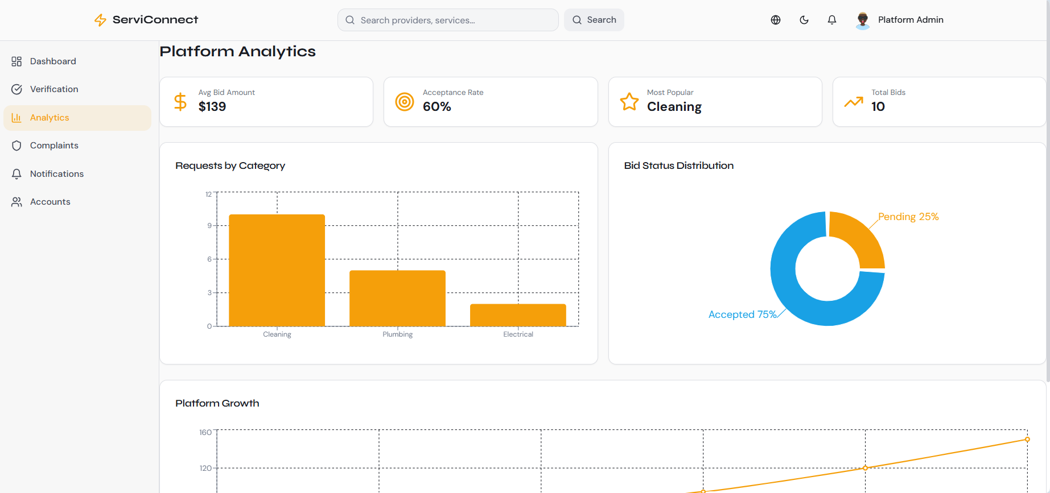
Figure 23 dashboard of Syrian Services Hub.

9.2 Comparative Analysis with Existing Systems
The benchmark study showed that existing platforms differ in their operating models. Some platforms focus mainly on ready-made services, while others focus on open service requests and competitive offers. Syrian Services Hub combines both models in one platform and adds recommendation-oriented support to improve service discovery and decision-making.
table 47 Comparative analysis between Syrian Services Hub and selected reference platforms.
Criterion | Khamsat / Fiverr | Mostaql / Upwork | Syrian Services Hub
Service model | Strong ready-made service model | Strong request and offer model | Hybrid model: services + requests + offers
User decision support | Mostly based on browsing and ratings | Based on proposals, profiles, and filters | Recommendation support plus provider comparison logic
Local adaptation | General marketplace model | General freelance/project model | Adapted to a local service marketplace context
Trust features | Ratings and profile indicators | Verification, proposals, messages | Ratings, complaints, verification, and admin control
Smart feature | Limited or implicit | Limited or platform-specific | Problem-based recommendation for solutions and providers
Knowledge-grounded customer Q&A | Generally unavailable as provider-owned cited Q&A | Generally not a core marketplace workflow | Ask Assistant retrieves provider-owned evidence and returns cited answers or an insufficient-evidence response

9.3 Achievement of Project Objectives
The achieved results can be evaluated by comparing the implemented and designed system behavior with the objectives defined at the beginning of the project. The platform succeeded in addressing the major functional areas required for a smart service marketplace, including service discovery, service request posting, offer submission, interaction, trust-related functions, and recommendation support.
table 48 Achievement of the main project objectives.
Objective | Result / Evidence | Status
Connect consumers with service providers | The system supports users, providers, services, requests, and offers. | Achieved
Support hybrid marketplace workflows | The platform includes ready-made services and open service-demand advertisements. | Achieved
Improve trust and supervision | Ratings, complaints, verification, verification revocation, and admin monitoring are supported. | Achieved
Provide intelligent recommendation support | The user enters a problem and receives suggested solutions and a recommended provider. | Achieved
Support maintainable system design | The system follows a client-server and three-tier architectural structure. | Achieved
Provide grounded customer Q&A through Ask Assistant | The system separates RAG from recommendation, retrieves authorized provider evidence, returns citations, and handles insufficient evidence safely. | Achieved

9.4 Strengths and Limitations
The project has several strengths that make it suitable as an academic software engineering solution. It combines multiple service-marketplace workflows in a unified platform, supports several user roles, and includes trust-related mechanisms that improve platform reliability. The recommendation feature also adds a smart dimension by helping users move from a problem description to suggested solutions and a suitable provider. However, the project also has limitations, especially because it was developed within an academic timeframe. Some advanced production-level features, such as full payment integration, large-scale deployment optimization, and extensive real-user evaluation, can be considered future improvements rather than core requirements of the current version.
table 49 Summary of project strengths and limitations.
Strengths | Limitations
Hybrid service marketplace model combining services, requests, and offers. | No complete online payment workflow in the current academic scope.
Clear role-based structure for visitor, user, provider, and admin. | Large-scale production deployment remains a future enhancement.
Trust mechanisms through ratings, complaints, verification, and admin control. | Recommendation quality can be improved later with more data and advanced models.
Recommendation feature supports users with suggested solutions and providers. | Usability testing with a large number of real users is still limited.
Separate RAG architecture with provider-owned knowledge, permission-aware retrieval, citations, and explicit insufficient-evidence handling. | Answer quality depends on the completeness, freshness, and clarity of provider knowledge sources and requires broader real-world evaluation.

9.5 Key Performance Indicators
Key performance indicators are used to evaluate whether the system provides acceptable quality from functional, usability, and operational perspectives. Since the project is developed in an academic context, the indicators are used mainly to guide evaluation and future improvement rather than to claim large-scale production performance.
table 50 Suggested KPIs for evaluating Syrian Services Hub.
KPI | Evaluation Focus | Expected Direction
Response time | Speed of browsing, searching, and submitting requests or offers | Fast and acceptable for normal academic testing
Requirement coverage | Coverage of functional requirements by design and test cases | High coverage for core requirements
Recommendation relevance | Suitability of suggested solutions and providers to the entered problem | Relevant recommendations for common problem descriptions
Usability | Clarity of main user paths and ease of interaction | Simple and understandable workflows
Reliability | Correct handling of roles, data, complaints, and verification status | Consistent behavior across main scenarios
RAG grounded-answer rate | Percentage of supported answers with valid citations and percentage of unsupported questions safely rejected | High citation coverage with no cross-provider evidence leakage
Overall, the results show that Syrian Services Hub provides a coherent and practical solution for organizing service discovery, provider interaction, request management, offer submission, trust control, and recommendation support. The project therefore achieves its main academic and practical goals while leaving clear directions for future enhancement.

Chapter Ten: Conclusion and Recommendations
This chapter concludes the thesis by summarizing the main outcomes of Syrian Services Hub, identifying the principal challenges faced during the project, and presenting future development directions and recommendations. It also reflects on the overall value of the platform as a structured digital service marketplace supported by intelligent recommendation functionality.

10.1 Project Summary and Main Achievements
Syrian Services Hub was designed as a smart digital service marketplace that connects consumers with service providers through a structured and accessible web-based platform. The project addresses the problem of scattered service discovery by offering a unified environment where users can browse services, publish service-demand advertisements, receive offers from providers, communicate with them, and make more informed decisions. The system supports the main roles required by the platform, including visitors, registered users, service providers, and administrators.
The main achievement of the project is the development of a hybrid marketplace model that combines direct service publishing with open service requests and offer-based interaction. This structure reflects the benchmark study findings, where existing service platforms commonly provide either ready-made services, open project requests, or a combination of both. The project also includes trust-supporting features such as ratings, complaints, verification, administrative monitoring, and the ability to revoke verification when needed. In addition, the recommendation feature strengthens the intelligent aspect of the project by allowing users to describe a problem and receive suggested solutions together with a suitable service provider suggestion.
A further achievement is the implementation of Ask Assistant as an independent RAG capability. It introduces provider-managed knowledge ingestion, vector retrieval through PostgreSQL and pgvector, authenticated provider-specific question answering, citation persistence, and safe insufficient-evidence handling. Its separation from AI Recommendation preserves a clear responsibility for each intelligent feature.
table 51 Summary of main project achievements.
Achievement Area | Summary
Marketplace Structure | The system supports both ready-made services and user-published service-demand advertisements.
Provider Interaction | Service providers can publish services and submit offers to user requests.
Trust and Supervision | Ratings, complaints, verification, and administrative control improve platform reliability.
Recommendation Support | The platform supports problem-based recommendations that return suggested solutions and suitable providers.
Engineering Documentation | The project includes structured requirements, design models, implementation description, and testing documentation.
Ask Assistant (RAG) | The platform supports provider-owned knowledge ingestion and evidence-based customer answers with citations, separately from AI Recommendation.

10.2 Difficulties and Challenges
Several challenges were encountered during the development and documentation of Syrian Services Hub. One major challenge was managing the wide functional scope of the platform, since the system includes accounts, profiles, services, requests, offers, messaging, ratings, complaints, verification, dashboards, and recommendation support. These modules are connected to each other and require consistent analysis, design, and implementation decisions.
Another challenge was maintaining alignment between the academic documentation and the actual software implementation. Since the project evolved through incremental development, several requirements and design decisions required refinement to remain consistent with the final system structure. The recommendation feature also introduced an additional challenge because it had to provide meaningful support to users without becoming disconnected from the platform’s marketplace purpose. Time limitations and the need to prepare diagrams, tables, testing results, and formal documentation also increased the complexity of completing the project within the academic timeframe.
The RAG component introduced additional challenges in document ingestion, chunk sizing, vector retrieval, provider-level authorization, citation integrity, and control of unsupported model output. These challenges were addressed through bounded knowledge and customer-assistant modules, permission-first retrieval, explicit source states, and grounding-focused response rules.
table 52 Main project challenges and responses.
Challenge | Project Response
Large functional scope | Core features were prioritized and grouped into logical modules.
Requirement refinement | Requirements and use cases were reviewed and adjusted during development.
Recommendation integration | The recommendation feature was linked to user needs, suggested solutions, and provider suggestions.
Documentation consistency | Analysis, design, implementation, and testing sections were aligned progressively.
Time constraints | The work was organized into phases to keep the project manageable.
RAG grounding and authorization | The project separated knowledge ownership from conversation handling, filtered retrieval before similarity search, persisted citations, and rejected unsupported answers.

10.3 Future Improvements
Although Syrian Services Hub provides a complete foundation for a smart service marketplace, several future improvements can increase its practical value. The recommendation feature can be enhanced through more advanced machine learning techniques, larger datasets, user behavior analysis, and personalized ranking. The platform can also be extended with more advanced provider comparison tools that consider ratings, response time, price range, service category, verification status, and previous activity.
Future versions of the system may also include stronger notification mechanisms, mobile application support, advanced analytics dashboards, multilingual expansion, and improved deployment scalability. If the platform is adopted in a real production environment, additional work may be required in performance optimization, security auditing, user feedback collection, and operational monitoring. These improvements can help transform the academic prototype into a more complete and production-ready service platform.
table 53 Suggested future improvements.
Improvement | Expected Benefit
Advanced recommendation model | Improves the relevance of suggested solutions and providers.
Enhanced provider comparison | Supports better user decision-making.
Mobile application support | Increases accessibility for users and providers.
Advanced analytics dashboards | Helps administrators and providers monitor platform activity.
Performance and security hardening | Improves readiness for real deployment.
RAG evaluation and ingestion automation | Improves retrieval quality through benchmark question sets, automated source refresh, hybrid search, reranking, and continuous citation-quality monitoring.

10.4 Recommendations
Based on the project outcomes, it is recommended that future development of Syrian Services Hub should continue to follow a modular and requirement-driven approach. The core marketplace workflows should remain stable and clear before adding more advanced features, because the value of the platform depends on the reliability of its main service, request, offer, and communication processes. It is also recommended to keep the intelligent recommendation feature closely connected to real user needs, rather than treating it as an isolated technical addition.
From a software engineering perspective, future work should preserve traceability between requirements, design, implementation, and testing. This helps maintain project quality and makes future maintenance easier. It is also recommended to continue improving trust-related mechanisms, including verification, complaint management, rating quality, and administrative review. Finally, any future deployment should be supported by real user testing, performance monitoring, and security review to ensure that the platform remains usable, reliable, and safe in practical environments.
table 54 Final recommendations.
Recommendation | Purpose
Keep the core marketplace workflows simple and reliable. | Protect the main user journey from unnecessary complexity.
Improve recommendation quality gradually. | Ensure that intelligent support remains useful and relevant.
Maintain traceability across the project lifecycle. | Support future maintenance and academic consistency.
Strengthen trust and supervision mechanisms. | Increase confidence between users and providers.
Conduct real-user validation before production deployment. | Verify usability, performance, and practical acceptance.
Preserve the separation between AI Recommendation and Ask Assistant. | Keep provider ranking and service suggestions independent from evidence-based factual question answering.

10.5 Closing Statement
Syrian Services Hub demonstrates how a local service marketplace can be organized, analyzed, designed, implemented, and evaluated using software engineering principles. By combining service discovery, service requests, provider offers, trust mechanisms, administrative supervision, and recommendation support, the project presents a practical and academically grounded solution for improving the interaction between consumers and service providers. The project therefore provides a strong foundation for future development and for further enhancement of smart service marketplace systems.
With the addition of Ask Assistant, the project also demonstrates how provider-owned knowledge can be transformed into permission-aware, cited customer support while remaining distinct from recommendation logic. This strengthens the platform’s transparency and creates a clear foundation for future RAG evaluation and production hardening.

Section Six: Appendices and References
Appendices
The appendices provide supporting material for the analysis, design, implementation, and testing activities discussed in the thesis. Detailed diagrams and screenshots may be inserted in their corresponding locations or attached in the appendices when preparing the final print version.
table 55 Appendix Overview
Appendix | Content | Purpose
Appendix A | Requirements and use case support | Supports Chapter Four analysis and traceability.
Appendix B | Design diagrams and architecture figures | Supports Chapter Five design explanation.
Appendix C | Implementation screenshots and interface samples | Supports Chapter Seven implementation description.
Appendix D | Testing evidence and detailed results | Supports Chapter Eight validation activities.
Appendix E | User guide or operational notes | Supports installation and basic use if required.
Appendix F | Ask Assistant RAG architecture, API, ingestion, retrieval, and validation evidence | Supports the RAG requirements, design, implementation, testing, and traceability additions.
References
The following references include the official sources used in the benchmark study, the technical documentation related to the implementation stack, and the project repository used to verify implementation details. A single numbered reference style is used for consistency.
[1] Khamsat Support Center, FAQ and profile settings documentation. Available: https://support.khamsat.com/
[2] Mostaql Support Center, FAQ, completion rate, and offer package documentation. Available: https://support.mostaql.com/
[3] Fiverr Help Center, Creating a Gig and seller workflow documentation. Available: https://help.fiverr.com/
[4] Upwork Help Center, Project Catalog, proposals, direct messages, verification, and Trust and Safety resources. Available: https://support.upwork.com/
[5] Freelancer Support Center, milestone payments, KYC, and dashboard documentation. Available: https://www.freelancer.com/support/
[6] PeoplePerHour Support Center, escrow and project protection documentation. Available: https://support.peopleperhour.com/
[7] React Documentation. Available: https://react.dev/
[8] TypeScript Documentation. Available: https://www.typescriptlang.org/docs/
[9] Django Documentation. Available: https://docs.djangoproject.com/
[10] Django REST Framework Documentation. Available: https://www.django-rest-framework.org/
[11] PostgreSQL Documentation. Available: https://www.postgresql.org/docs/
[12] Vite Documentation. Available: https://vite.dev/guide/
[13] Postman Learning Center. Available: https://learning.postman.com/
[14] GitHub Documentation. Available: https://docs.github.com/
[15] Syrian Services Hub project repository. Available: https://github.com/lilasnkl/Syrian
[16] Syrian Services Hub, “Customer Q&A RAG With OpenAI,” project architecture documentation, available in the project repository.
[17] OpenAI API Documentation, Embeddings and Responses API. Available: https://platform.openai.com/docs/
[18] pgvector Documentation. Available: https://github.com/pgvector/pgvector

